The Official Publication of ALOA An International Association of Security Professionals

PLUS!

Greg Perry Hits the “Marks” Building Customer Rapport Innouation and More!

***#**********#***Sqj_[*** ^-II ]C} IT 303 Breck H. Camp CML PO Box 47070 Atlanta GA 30362-0070

l„ll,ll

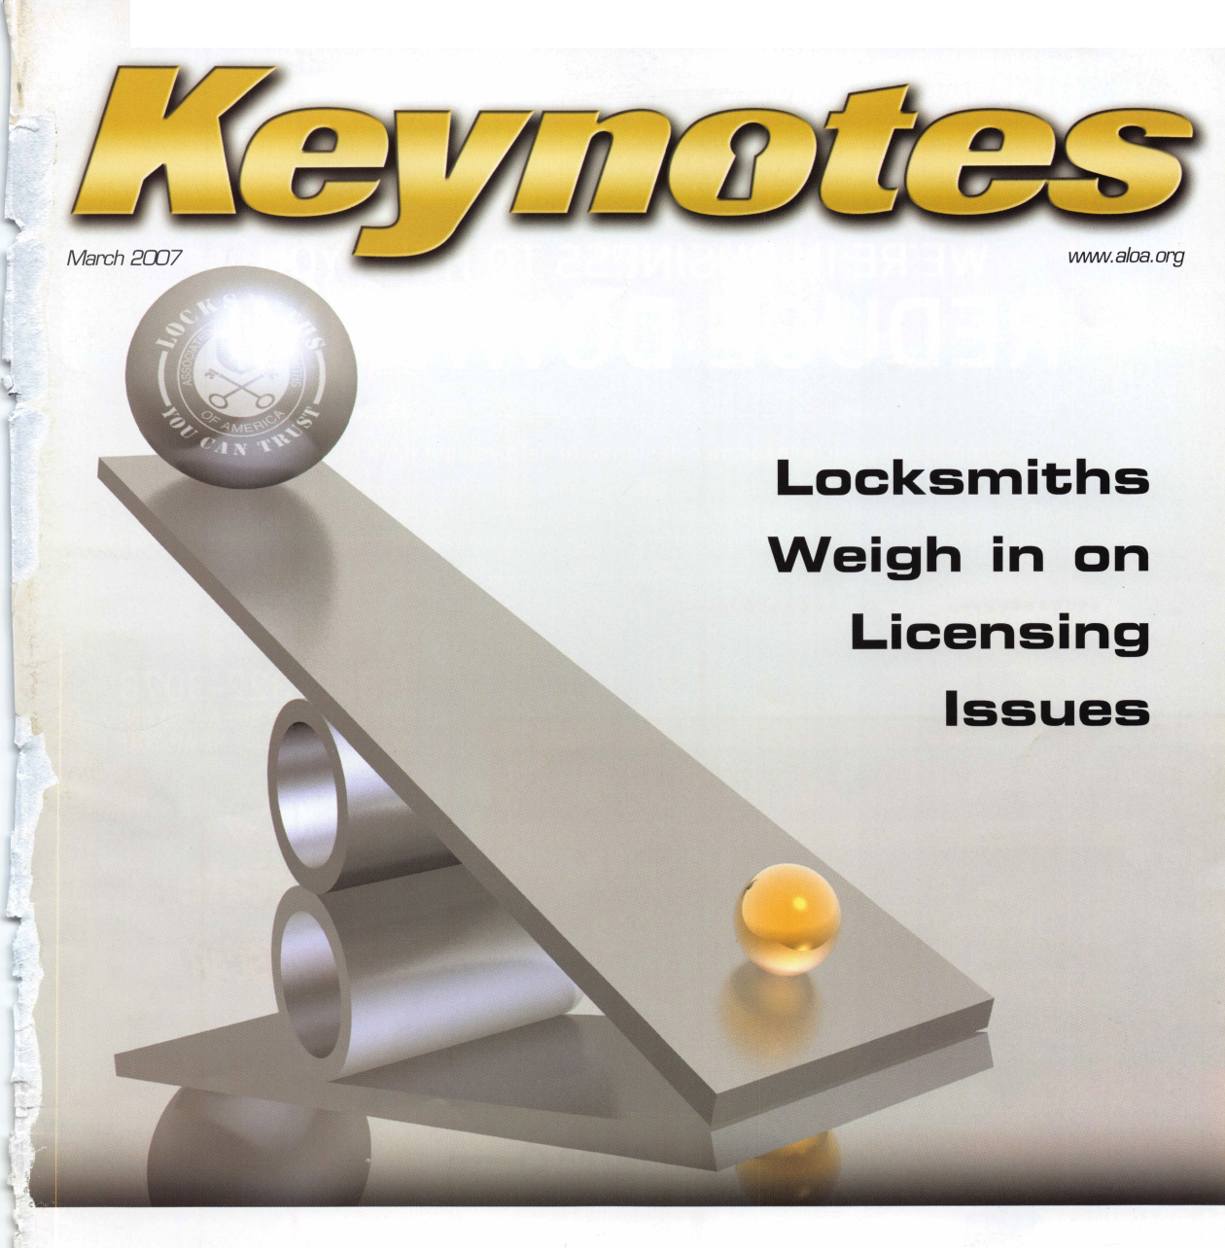

**OUR STAND**

***\***

.i|

*■m*

**WE’RE IN BUSINESS TO HELP YOU ]**

**REDUCE DOWNTIME.**

**LOCKSMITHS**

**Commercial vehicle insurance designed to help you get back on the road.**

When your vehicle jis out of business, so are commercial vehicle insurance as well as other you. That's why Allstate provides fast and fair insurance products designed to help keep your

claim service. Yourjlocal Allstate agent offers business in the race. Are you in Good Hands®?

CALL NOW TO SPEAK TO AN ALLSTATE AGENT NEAR YOU

; »

/instate

**Subject to availability and qualifications. Allstate Insurance Company and Allstate Indemnity Company, Northbrook, IL. Allstate County Mutual Insurance Company, Irving, TX. Allstate New Jersey Insurance Company Bridgewater, NJ. The “Cupped Hands" logo is a registered service mark and "Our Stand" is a service mark of Allstate Insurance Company. NASCAR® is a registered trademark of the National Association for Stock Cat Auto Racing, Inc. ©2007 Allstate Insurance Company, Northbrook, IL.**

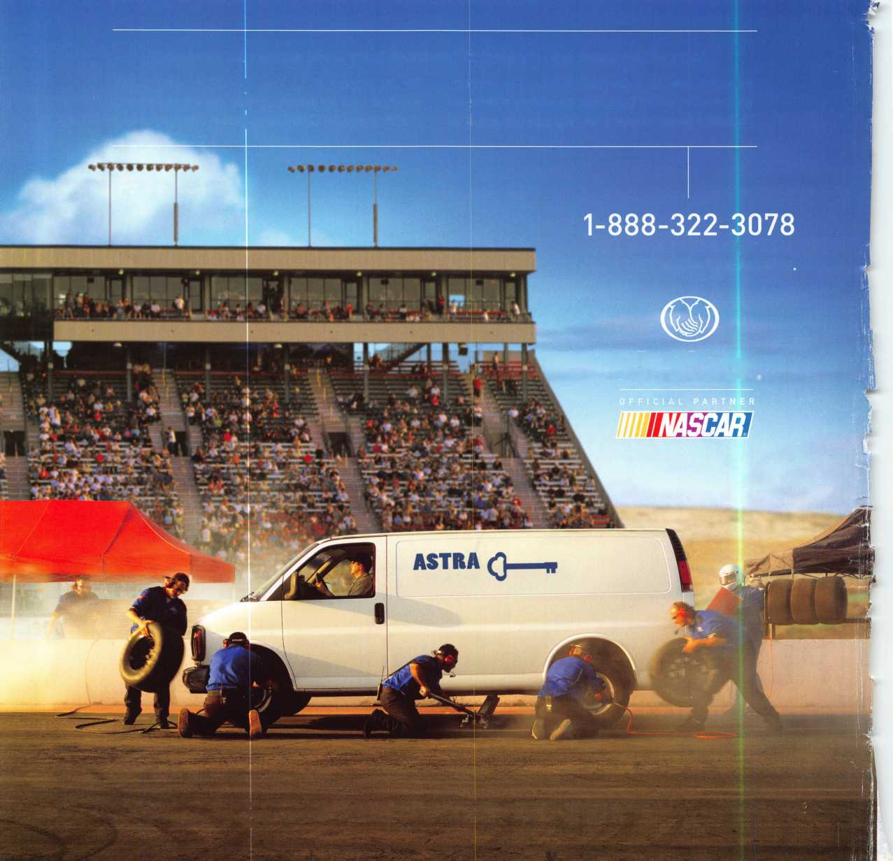

A Name You Know

As a business owner, you know the importance of a good name. Your name is your reputation. Your name stands for all that you offer in products and services. It’s a symbol of who you are. So, we thought you might like to know that Allstate, the name you know for insuring your personal vehicle and your home, also offers a business auto policy to help protect vehi­cles used in your locksmith business.

The following are coverages typically included in our business auto policy that might be important to you as a business owner:

Business Auto Liability coverage

* Higher limits up to $2,000,000 per occur­rence.
* Protects you if you are legally responsible for injuries and damages arising out of the ownership, maintenance, or use of business vehicles.
* Cost is based on several factors, includ­ing garage location, type and use of vehi­cle, and the violation and accident activi­ty of your drivers.
* Additional Insured coverage may be required when you contract with govern­mental agencies or bid on local commercial jobs.
* Generally not available on a personal auto policy.
* Usually is no charge to add an insured to a Commercial Auto policy.

Hired Auto coverage

* Provides liability coverage for those vehicles you rent, hire or borrow for business use.
* The premium for hired auto liability coverage is based on the estimated annual rental cost.
* Tools and Special Equipment
* Provides protection to permanently attached equipment on your vehicle.
* You will need to let your agent know the value of the equipment to include in the cost of the vehicle.

You’re good at your business. Your insurance com­pany should be the same way.

Contact an Allstate agent to discuss your business auto insurance needs. To be referred to an agent, please call 800.859.0247 or email abisO@allstate. com.

Subject to availability and qualifications. Insurance coverage is subject to policy terms.

Allstate Insurance Company

Allstate Indemnity Company Northbrook, IL

Allstate County Mutual Insurance Company Irving, TX

Allstate New Jersey Insurance Company Bridgewater, NJ

allstate.com

LOiJJULI

uudjiiu

LDGDCD

l_J ~t

Need information in a hurry?

Use ALOA’s Fax On Demand service

Just call 310-575-5027 and receive:

1. ALOA Index of Documents (1 pg)
2. Reasons to Join ALOA (2 pg)
3. Locksmith Career Summary (3 pgs)
4. Locksmith School List (1 pg)
5. ACE Class Schedule (1 pg)
6. Certification Information (5 pgs)
7. PRP Category List (1 pg)
8. ALOA Membership Application (1 pg)
9. ALOA List of Benefits (1 pg)
10. ASF Scholarship Application (1 pg)
11. ASF Scholarship information (1 pg)
12. ALOA Video Library Order Form (1 pg)
13. Safe & Vault Technicians Association Membership

Application/Subscription Form (2 pgs)

1. Recertification Information (4 pgs)
2. Legislation Action Network Newsletter (2 pgs)
3. Various State Law Issues (8 pgs)
4. Industry Position Paper (1 pg)
5. ALOA Convention Class Schedule (3 pgs)
6. ALOA Convention Class Descriptions (30 pgs)
7. ALOA Convention Registration Forms (4 pgs)
8. Board of Directors Nomination Form (2 pgs)
9. ALOA Company Membership Application (2 pgs)

310**-**575-5027

© 2005 Allstate Insurance Company, Northbrook, IL

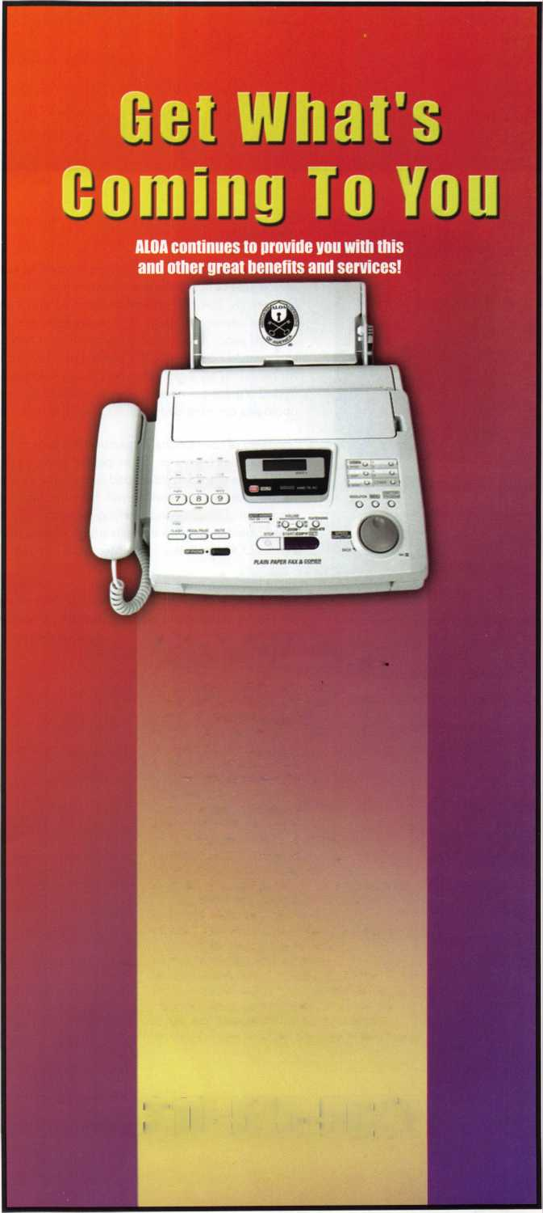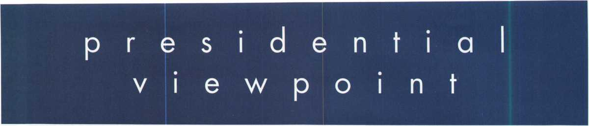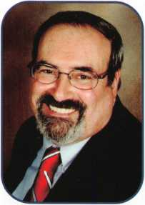

Dear Members,

The best part of my job as President is traveling to meetings and speaking with fellow locksmiths and seeing the human side of our profession. Besides time constraints, very few things prevent me from attending these meetings. Just recently, I was all packed and excited about attending the Texas Locksmith Association's convention. I had been asked to attend and speak at T.L.A. by Roy Yetter, their President. Roy had asked me when we were attending SER- LAC last year. After checking my calendar, I had agreed and was looking forward to talking with many friends that I knew would be attending the convention. I was at work, when around 1:00 PM my cell phone rang and it was US Air canceling my flight. Needless to say, I scrambled to find another flight. There was none to be had! I know that I missed a great convention. This was one of the few things that would prevent my attendance at an invited affair. My apologies are extended to all the members and friends at T.L.A. for these most unfortunate circumstances.

Speaking of conventions, remember, this year A.L.O.A. is in Charlotte, NC, July 22nd-29th. So, mark your calendar now and plan to attend. Some people always ask, "Why should I attend conventions?" The two most important rea­sons for me are educational and social. The education part includes the trade show, formal classes, free seminars, factory tours and networking with fellow locksmiths. The social part is meeting with all the friends Dee and I have made in this industry and catching-up with family news and reminiscing old times. Of course, this part cannot be appreciated unless you start attending conventions and meetings and get to know people. So let's see your face at the A.L.O.A. booth this year. Meet your regional director; it's a good start.

There has been more interest by the news media in bump keys. I urge all members to become aware of this prob­lem. Educate your customers. We also need all members to keep a sharp eye out for phony locksmiths. We need the victims of these unscrupulous people to document their experiences so we can forward the information to their State Attorney General's office. Together we can make a difference on both these issues by giving the public a safe place to turn, an A.L.O.A. locksmith.

Take 'er easy! 4

Sincerely,

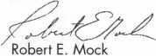

r

Keynotes • March 2007

Craft

your own career

in Locksmithing

Learn to be a locksmith at our conveniently  
scheduled hands-on morning program. Classes  
are given from 7:30 am - 12:30 pm. Over nine  
months you will learn to service, install and  
bypass a wide variety of locking devices including

residential, commercial and automotive locks. Master keying, electronic  
access, and safe manipulation round out a curriculum which is updated  
annually to incorporate the latest industry advancements. September and  
February admissions.

Other full-time courses offered are • Bookbinding • Cabinet & Furniture  
Making • Carpentry • Preservation Carpentry • Jewelry Making & Repair  
• Piano Technology • Violin Making & Repair

Financial aid is available for qualified students. Accredited member ACCSCT. Non-accredited workshops 1 week to 3 months also offered.

NORTH-BENNET-STREET-SCHOOL

AN EDUCATION IN CRAFTSMANSHIP 39 North Bennet St. • Boston, MA 02113 • (617) 227-0155

[www.nbss.org](http://www.nbss.org)

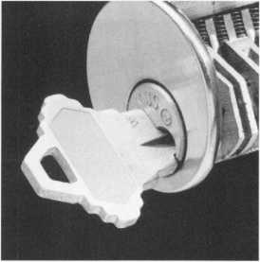

feat

LICENSING VIEWS 2007

10

Licensing Views

Locksmiths Weigh in on Licensing Issues.

by C.D. Lipscomb, CML, CPS, CIL

**14**

Member Spotlight:

**18**

Customer Rapport

Stop ignoring your customer. Read on to find out six expert techniques to building customer rapport.

by Laurie Brown

22

Something Old. Something New. Something Borrowed. Something Blue.

What brand are you married to? Greg Perry steps out of his box and shows us how we all could use a little change now and then.

by Greg Perry, CML, CPS

**30**

Innovation in the Global Marketplace

FireKing Security Group helps us understand the culture of innovation.

**42**

NASTF Press Release

NASTF board approves pilot testing for secure data release model.

u

r e

s

|  |  |  |  |
| --- | --- | --- | --- |
| r |  |  | I |
|  | AD INDEX | |  |
|  | Allstate | ..Inside Front Cover |  |
|  | Fax on Demand | 1 |  |
|  | North Bennet Street School | 3 |  |
|  | ALOA 2007 | 7 |  |
|  | Cal-Royal | 15 |  |
|  | BCASP | 16 |  |
|  | Ben Jim | 17 |  |
|  | Safetech 2008 | 19 |  |
|  | Letrotruck | 20 |  |
|  | PBP | 21 |  |
|  | Clearstar | 21 |  |
|  | Turn 10 | 23 |  |
|  | DKS | 25 |  |
|  | ALOA Golf Tournament | 27 |  |
|  | CSPEC | 28 |  |
|  | A&B | 29 |  |
|  | ALOA Member Recruitment | 31 |  |
|  | Ultralift | 33 |  |
|  | A&B | 40 |  |
|  | Locksmithing UNL | 40 |  |
|  | Coast Safe & Lock | 40 |  |
|  | HL Flake | 41 |  |
|  | Simon Voss | 43 |  |
|  | Jet Hardware | 44 |  |
|  | Door Jam Armor | Inside Back Cover |  |
|  | CCL | Back Cover |  |
| L |  |  | j |

**Departments**

|  |  |  |  |  |  |  |  |  |
| --- | --- | --- | --- | --- | --- | --- | --- | --- |
| Presidential |  | Executive | 5 | Calendar | 8 | Classified | 34 | Legislative 38 |
| Viewpoint | 2 | Applicants .... | 6 | Core | 9 | Associate Members | 36 |
|  |

Visit our NEW website at [www.aloa.org](http://www.aloa.org)

executive

**'-4** IV V*

Volume 53, Issue 3

Additional contact information for the ALOA Board is available on the ALOA website—  
[www.aloa.org](http://www.aloa.org) or by contacting the ALOA office at 3500 Easy Street; Dallas, TX 75247;  
(800)532-2562; FAX (214)819-9736; e-mail [aloa@aloa.org](mailto:aloa@aloa.org).

Editor & Director of Creative Services

Betty Southerland [betty@aloa.org](mailto:betty@aloa.org)

Advertising Sales

Kim Hammond voice: 817-645-6778

Fax: 817-645-7599 e-mail: [adsales@aloa.org](mailto:adsales@aloa.org)

Executive Director

Charles W. Gibson, Jr., CAE [charlie@aloa.org](mailto:charlie@aloa.org)

Associate Executive Director

David Lowell, CML, CMST [david@aloa.org](mailto:david@aloa.org)

Convention & Meetings Manager

Jo Anne Mims [joanne@aloa.org](mailto:joanne@aloa.org)

Operations/Membership Manager

Mary May [mary@aloa.org](mailto:mary@aloa.org)

Director of IT Operations

Greg K. Jackson [greg@aloa.org](mailto:greg@aloa.org)

Comptroller

Kathy Romo [kathy@aloa.org](mailto:kathy@aloa.org)

Membership Development Manager

Ellen R. McEwen [ellen@aloa.org](mailto:ellen@aloa.org)

Membership Coordinator Shelly Jett

Convention & Meetings Assistant Karen Lyons  
PRP/Education Coordinator Shelley Melton

Mail Room Coordinator Kevin Wesley

Graphic Designer Margarita Garza

Accounting Coordinator Joyce Nixon

Executive Assistant Sue Langford

Assistant Education Manager Bob Stafford, CML  
Legislative Manager Tim McMullen

Contributors

Jerome Andrews, CML  
Paul Chandler, CRL  
Claire Cohen, CML  
Brian Costley, CML, CMST  
Eric Costley, CRL

Ray D'Adamo, CML Billy Edwards, CML Dan Graffeo, CRL,CMST Jim Hancock, CPL Jeff Nunberg, CML, CMST

Randy Simpson, CML, CPP Robert Stafford, CML Dave Thielen, CML Greg Perry, CML,CPS

Tom Seroogy

Charles Stephenson, CPS

Dennis Watanabe, CML, CMST

**Mission Statement:** The Associated Locksmiths of America, Inc. is dedicated to enhancing the professionalism, education and ethics among  
locksmiths and those in related sectors of the physical security industry. With approximately 10,000 members in the United States, Canada and the  
freeworld, ALOA is poised to help members obtain the knowledge, the strength, and the confidence to perform their role in the physical security field  
with pride and dignity. But it is only through active involvement and participation that ALOA can fully achieve its potential—and can help members to  
achieve theirs.

**Policies:** Keynotes® is the official publication of the Associated Locksmiths of America, Inc. (ALOA). Keynotes® acts as a moderator without approving,  
disapproving, or guaranteeing the validity or accuracy of any data, claim, or opinion appearing under a byline or obtained or quoted from an acknowl-  
edged source. The opinions expressed by the authors do not necessarily reflect the official views of ALOA. Also, appearance of advertisements and  
new products or service information does not constitute an endorsement of products or services featured by the Association. The Association does not  
accept responsibility for the inaccuracy of any data, claim, or opinion appearing in this publication, due to typographical errors on the part of the  
authors, Association staff or its agents.

**Editor^ Note:** This publication is designed to provide accurate and authoritative information in regard to the subject matter covered. It is provided  
and disseminated with the understanding that the publisher is not engaged in rendering legal or other professional services. If legal advice and other  
expert assistance is required, the services of a competent professional should be sought.

**Authors7 Payment:** Payment for eligible submissions to Keynotes will be based on the following criteria: topic, time spent and past contributions. Authors who  
regularly submit to Keynotes® are generally paid a higher rate. The latter is especially true of authors who write to fit specific editorial needs and submit said copy  
by Keynotes® deadlines. As a general guideline: Average payment for a 750 word, business or light' technical article would be $200. Payment for a 1500 word  
article involving significantly higher time and research efforts would be $400.

Payment will not be offered for articles submitted by ALOA employees or members of the ALOA Board of Directors (unless material is of a technical  
nature), nor for articles submitted by a company that promote that company's products or services. ALOA reserves the right not to pay for articles sub-  
mitted by an individual(s) that promote a particular company's products or services.

**Disclaimer:** The Associated Locksmiths of America, Inc., (ALOA), reserves the right to refuse any article for any reason. Additionally, ALOA reserves  
the right to edit, amend or modify any article submitted for publication in order to preserve technical accuracy, clarity, fairness or grammatical correct-  
ness. ALOA will make the best efforts to notify the author of any changes. The extent of ALOA's liability for any article or information contained there-  
in will be a notice of correction or retraction in the next possible issue.

Keynotes® (ISSN 0277 0792) is published monthly except for the combined June/July issue by The Associated Locksmiths of America, Inc.,  
3500 Easy St., Dallas, TX 75247-6416. Telephone: (214) 819-9733; FAX (214) 819-9736; e-mail [aloa@aloa.org](mailto:aloa@aloa.org). Subscription rates for  
members—$15.00 per year. Periodical class postage paid at Dallas, Texas. POSTMASTER: Send address changes to: Keynotes, 3500 Easy St., Dallas,  
TX 75247-6416. © Copyright 2003, All rights reserved. No part of the contents may be reproduced or reprinted in any form without prior  
written permission of the publisher.

President

Robert Mock

(856) 863-0710  
[president@aloa.org](mailto:president@aloa.org)

Secretary

John Soderland, CML, CMST  
(414) 327-5625  
[secretary@aloa.org](mailto:secretary@aloa.org)

Directors, Northeast

Tom Foxwell  
(410) 206-5772  
[nedirector@aloa.org](mailto:nedirector@aloa.org)

Robert D. DeWeese, CML, CPS  
(410) 285-0101  
ned i rector@a loa.org

Directors, Southeast

Tom Gillingham, Jr., CML, CPS  
(615) 264-0747  
sedirector@aloa .org

Ken Kupferman, CML, CPS  
(813) 232-7600  
sed i rector@a loa. org

Director, North Central

William Smith, RL  
(920) 893-5282

Guy Spinello, RL  
(815) 394-1000  
ncdirector@aloa .org

Director, South Central

CD Lipscomb, CML, CPS  
(903) 874-3522  
scdi rector@aloa. org

Directors, Southwest

Greg Parks, CRL  
(858) 271-1155  
swdirector@aloa. org

Julie McCluney, CRL  
(714) 636-5652  
s wd i rector@a loa. org

Director, Northwest

Keith E. Whiting, CML, CFL  
(360) 601-5656  
[nwdirector@alod.org](mailto:nwdirector@alod.org)

Director, European

Hans Mejlshede, CML  
(453) 539-3939  
eurdirector@aloa. org

Director, Associate

Dan Floeck  
(800) 231-4105  
asd i rector@a loa. org

Trustees

[trustees@aloa.org](mailto:trustees@aloa.org)

Randy Simpson, CML, CPP  
(281) 240-5959

JohnJ. Greenan, CML, CPS  
(773) 486.2030

William Young, CML, CPS  
(610) 647-5042

Past Presidents

2003-2005 William Young, CML, CPS  
2001-2003 Randy Simpson, CML  
1999-2001 John Greenan, CML, CPS  
1997-1999 Dallas C. Brooks  
1995-1997 David Lowell, CML, CMST  
1993-1995 Breck Camp, CML  
1991-1993 Henry Printz, CML  
1989-1991 Evelyn Wersonick, CML, CPS  
1987-1989 Leonard Passarello, CPL  
1985-1987 Joe Jackman, CML  
1983-1985 Stanley Haney, CPL  
1981-1983 Louis LaGreco, CPL  
1979-1981 John Kerr, RL  
1977-1979 Clifford Cox, CML  
1974-1977 Charles Hetherington  
1972-1974 Gene Laughridge  
1970-1972 William Dutcher, RL  
1968-1970 Constant Maffey, RL  
1966-1968 Harold Edelstein, RL  
1964-1966 William Meacham  
1962-1964 Robert Rackliffe, CPL  
1960-1962 Edwin Toepfer, RL  
1956-1960 Ernest Johannesen



Keynotes • March 2007

**5**

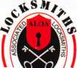

applicants

for membership

|  |  |  |  |  |
| --- | --- | --- | --- | --- |
| z | 1 1 | IN | Sponsor: Jeremy M. Sponsor: Jay J. Musselman | Ireland |

E

Chandler

Robert Jackson Jr.

Sponsor: Robert P. McDermed CRL

Camarillo

Dennis L. Cohea

Los Angeles

Yariv Shochat

Pueblo West

James A. Hinojosa Sr

Sponsor: John L. Shandy

Apollo Beach

Terry Lutthans

Crystal River

Gary Frasher

Sponsor: Douglas W. O'Connell

Ocoee

Thomas G. Tusing

Sponsor: Steven R. Myslik

Orlando

Timothy Kasper

Sponsor: Ken Kupferman CML, CPS

Pembroke Pines

Carlos Cancel

Winterville

Herman T. Fields

Bettendorf

Evansville

Andrew F. Rowe

Sponsor: Ric Conner CPL

Lawrenceburg

Norman C. Kirby

Brighton

Calvina Wong

Sponsor: David A/I. Troiano Dorchester

Jeffrey B. Champion

Sponsor: David A/I. Troiano Edgartown

Eugene G. Courtney

Sponsor: David A/I. Troiano Northampton

Cole S. Bushwa

Sponsor: David A/I. Troiano West Roxbury

Barbara B. Zillman

Sponsor: David A/I. Troiano Weymouth

Michael T. Diamond

Sponsor: David A/I. Troiano Winthrop

Apostolos Papavas- siliou

Sponsor: David A/I. Troiano Glen Arm

Francis J. Van Blargan

Sponsor: Tom Foxwell Sr Middle River

Golden Valley

Michael C. Sullivan

Sponsor: Mark D. Johnson CPL

Saint Paul

Ronnie E. Taggart

Sponsor: Dana L. Lee CML

Jay D. Hanson

Mo nett

Brent Peterson

Sponsor: Clifford D. Lip­scomb CML, CPS

Saint Louis

Daniel Gurvis

Concord

Jeff J. Garris

Carlsbad

Michael R. Herndon

Sponsor: Charles E. Batcke

opor

CRL,

CPS

Brooklyn

Itzhak Hizami

Churchville

Allan S. Tetreault

Sponsor: Richard S. Par­adise CRL

East Islip

Howard Castleman

Sponsor: Robert W. Grudens

Rodney Caden

Sponsor: Jeffrey C. Reese CPL, CPS

Mayaguez

Jesus M. Rivera

Barrington

Bretten Keightley

Sponsor: David A/I. Troiano

Nashville

Bill Crousser

Houston

Rodrigo Lima

Sponsor: Ricardo Torres Katy

Gregory T. Gilbert

Sponsor: Randy L. Simpson CML, CPP

Arlington

Eric A. Bosch

Sponsor: Michael B. Groves

Francisco A. Orellana

Sponsor: Michael B. Groves

Charles Town

James E. Rednowers Jr

Sponsor: Robert D. Smith

Australia

Melbourne Victoria

Allan Jones

|  |  |  |  |
| --- | --- | --- | --- |
| Jeff L. Kling | Alan L. Van Gelder | Cincinnati | Canada |
| Ql | Sponsor: Tom Foxwell Sr | James M. Kirby | ON |

Chicago

Herman Gonzalez

Sponsor: Paul Leys CRL East St. Louis

Philip Boyajian

Waukegan

Sam Davis

Birmingham

Ronald Rovinsky

Ferndale

Aron Boag

Sponsor: John K. Hubei CML

Grand Blanc

Andrew H. Tenneriello

Sponsor: Jim Williams CRL Massillon

Shawn E. Baltzer

Toledo

Gary Tressler

Port Royal

David Shafferman

Carlisle

Doug Handy

Cornwall

Sean Villeneuve

Dorval Montreal

Nicholas David, S Sup

Sponsor: Zenon A. Myziuk

Kildare

Terry Kinsella

IE

Chris Braiden

Miyawaka-Shi Fukuok

Keizo Tokunaga

Spon

Tsu MIE

Toshiya Takagi

Sponsor: Takashi Kuwana CRL

Yokohama-Shi Kanaga

Yoshitaka Nakazato

Sponsor: Takashi Kuwana *CRL*

Chung Nah

Sung Youl Jin

Sponsor: Chel-Ho Shin RL Chungcheongbuk-do

Nam Ki Hyun

Gang Won-Do

Sung Hak Kih

Sponsor: Chel-Ho Shin RL Junnah

Suk Hoon Han

Sponsor: Chel-Ho Shin RL Seoul

Gang Ok Lee

Sponsor: Chel-Ho Shin RL

Dong Ju Ahn

Sponsor: Chel-Ho Shin RL

Singapore

Singapore

Eric Phoon

Sponsor: John Woon RL

Sponsor: Daniel Simon Sel- vam

David Lim

Sponsor: Daniel 5. Selvam

These applicants are scheduled for clearance as members of ALOA. The names are, .  W1 11M

Protests, if any, should be addressed to the Membership Department and must be signed. Active Membership applicants (a) have worked in the industry two

published for member review and comment within 30 days of this Keynotes issue date, respectively, to ensure applicants meet standards of ALOA's Code of Ethics,

idive Membership applicants (a) have worked in the industry two or more years. Allied Membership (AL) applicants are not locksmiths, but work in a security-related field.  
Apprentice Membership (AP) applicants have worked in the industry less than two years.

Keynotes • February 2007



Start Your Engines!

This year, with a great location and a schedule chock-full of exciting classes and events, we are pulling out all the stops to celebrate the ALOA Convention and Security Expo in Charlotte, North Carolina.

Having built an international reputation among locksmiths as a powerful resource to explore industry innovation and form industry alliances, ALOA 2007 is the ideal place to learn, network or to showcase your security-related business on the show floor.

This year weve thought of everything from an exciting location to a comfort­able hotel and a convention center that is equipped to handle your every need. The exhibit hall promises to be overflowing with the latest technology and new mer­chandise.

july 22-29, 2007

charlotte, north Carolina

'4 k

**S3 / 5 '**

x1OOar/mir> Q a

2 f I

♦

7i

**a1_OA** 2007 **B**

1

aloa convention and security expo

*51****st ANNUAL***

**Don't miss out**

upcoming events

|  |  |  |  |  |  |
| --- | --- | --- | --- | --- | --- |
| O' | 3/7 | TBA • Franklin, Ohio  Ohio Valley Chapter Meetin |  | 3/28-30 ISC West Expo • Las Vegas, NV  Sands Expo & Convention Center | 3/31-31 34th Annual TAOL Convention  The Association of Ontario Locksmiths |
| < | 3/31-4/5 | Safetech 2007 • Lexington, | KY | (800) 840-5602 | Toronto, Ontario, Canada |
| £ |  | Safe & Vault Technicians As [www.savta.org](http://www.savta.org) | ociation |  | [www.taol.net](http://www.taol.net) |

4/4 Hometown Buffet • Franklin, Ohio Ohio Valley Chapter Meeting Contact: Chairman Terry McClain, CRL 513-464-8806

4/4 Counter Days 4/18 Doyle University Minneapolis, MN Doyle Security Products For more info [www.doylesecurity.com](http://www.doylesecurity.com)

4/26-28 Louisiana-Mississippi Locksmith Association Convention, Classes, & Dealer Show Paragon Casino & Resort Marksville, LA • [www.loumiss.org](http://www.loumiss.org)

5/1 Counter Days  
5/16 Doyle University  
Minneapolis, MN  
Doyle Security Products  
For more info [www.doylesecurity.com](http://www.doylesecurity.com)

6/6 Counter Days • Minneapolis, MN

Doyle Security Products

RCI with Mark Schrantz • [www.doylesecurity.com](http://www.doylesecurity.com)

5/4-6 Wyoming Locksmiths Assc. Trade Show

Casper, Wyoming  
Jim O'Grady • 307-234-5932

5/18-20

ELF Convention 2007 • Riga, Latvia European Locksmith Federation Exhibition - Social events -Education [www.elf2007.com](http://www.elf2007.com) • [ruta.reinika@prplus.lv](mailto:ruta.reinika@prplus.lv)

9/14-15 Doyle Annual Trade Show & Education • Prior Lake, MN Doyle Security Products Mystic Lake Casino [www.doylesecurity.com](http://www.doylesecurity.com)

**UPCOMING ACE CLASSES**

March 8-9, 2007

March 15-16, 2007 March 28 - 30, 2007

April 14-15, 2007 April 21, 2007 April 26 - 28, 2007

May 7 - 12, 2007

May 17-19, 2007

June 9, 2007

June 9-10, 2007

Lexington, KY • SAFETECH 2007

For specific course schedule please contact:

ALOA Education • [education@aloa.org](mailto:education@aloa.org)

800-532-2562x104

Northbrook, IL • Clark Security Products

For specific course schedule please contact:

Joan Emrick • 858-974-6737

Vancouver, British Columbia • British Columbia

Association of Security Professionals

Bill Beazley • 14 ALOA Certified Classes

[lockpicker@helmz.com](mailto:lockpicker@helmz.com) • 604-291-0444

Kansas City, MO • Missouri-Kansas Locksmith Assc.

For specific course schedule please contact:

Bob Turner • 816-525-5522

Kearney, NE • Nebraska Chapter of ALOA

Push Button Mechanical Lock Manipulation

Elmer Howard • [safeman@cox.net](mailto:safeman@cox.net) • 402-676-8973

Denver, Colorado • Central & Southern Colorado

Locksmths Association • 9 ALOA Certified Classes

Contact: Barry Meyers, CPL • 303-688-1404

Dallas, Texas • ALOA Training Center

Six-Day Basic Locksmithing Course

ALOA Education • [education@aloa.org](mailto:education@aloa.org)

800-532-2562x104

Dallas, Texas • ALOA Training Center

3-Day Automotive Locksmith Course

ALOA Education • [education@aloa.org](mailto:education@aloa.org)

800-532-2562x104

Birmingham, AL • Alabama Chapter of ALOA Basic Safe Penetration • Dallas Brooks 334-826-8990

Dallas, Texas • ALOA Training Center Keyless Mechanical Lock Servicing w/L20 PRP Push Button Mechanical Lock Manipulation ALOA Education • [education@aloa.org](mailto:education@aloa.org) 800-532-2562x104

**UPCOMING PRP Sittings**

3/10/07 Saturday 8:00am • Lexington, KY • ALOA Certification

SAFETECH2007 • [education@aloa.org](mailto:education@aloa.org) • 800-532-2562x104  
3/18/07 Sunday 8:00am • Northbrook, IL • Joan Emrick

Clark Security Products • 858-974-6737  
3/25/07 Sunday 8:00am • Novi, Ml • Bonnie Weston

IDN Hardware Sales* 313-591-1150

3/31/07 Saturday 8:00am • Vancouver, BC • ALOA Certification

British Columbia Association of Security Professionals  
[education@aloa.org](mailto:education@aloa.org) • 800-532-2562x104  
4/28/07 Saturday 8:00am • Roseville, Ml • Robert C. Noble, CML

Locksmith Security Association • 810-385-9329  
4/28/07 Saturday 6:00pm • Denver, CO • Barry Meyer, CPL

Central & Southern Colorado Locksmiths Association  
303-688-4104 • [acomal@gwest.net](mailto:acomal@gwest.net)

5/12/07 Saturday 1:00pm • Dallas, TX • ALOA Certification

ALOA Training Center • [education@aloa.org](mailto:education@aloa.org) •  
800-532-2562x104

6/17/07 Sunday 8:00am • Sparks, NV • Joan Emrick

Clark Security Products • [joan.emrick@clarksecurity.com](mailto:joan.emrick@clarksecurity.com)  
858-974-6737

**Contact the ALOA Education  
Department for a list  
of classes and training  
offered in-house.**

*

**core**



FireKing Awarded Patent for Centralized Electronic Safe and Accounting System

FireKing, one of the premier security products companies in the nation, recently announced that on June 20, 2006, the company was awarded a patent (U.S. Patent # 7,063,252) for its "Centralized Electronic Safe and Accounting Control System." The patent relates to the system and method for cost-effective and secure cash handling for merchants. The system allows retailers to place electronic safes at cash registers throughout the store with the safes networked together as one system, vastly simplifying the accounting process and adding efficiency to the cash handling process.

The now patented Centralized Electronic Safe and Accounting Control System provides users unprecedented efficiency, convenience, automation, and control for merchants to collect, process and verify cash, and can be used in a stand-alone operation, or as a central control-and-reporting unit for a digitally linked network of interconnected safes and currency counting and validating machines. In addition, the setup enables the automation of the cash reconciliation process with the POS system and allows for remote administration and updating of the system from a centralized, remote loca­tion.

The basic Centralized Electronic Safe and Accounting Control System con­sists of an electronic lock and money control system that is capable of oper­ating in a single unit stand-alone function, as well as expandability to a network of multiple units having one of the units operate as a centralized network controller. The network includes at least one safe provided with a control system arranged to communicate with a data input device, electron­

ic display, connector interface and electronic lock mechanism located on the safe. This is important for merchants who collect process and recycle large amounts of cash on a regular basis - this innovation enables them to cost effectively integrate additional system units as well as provide more efficient and secure system management and accounting operations.

According to Scott Meeker, FireKing Security Group Senior V.P., "The award of this patent for the Centralized Electronic Safe and Accounting Control System will both confirm FireKing's innovative approach to cash handling, and bolster our position as an industry leader."

4000 Series to E-Plex Migration

Kaba's E-Plex electronic access controls offer a full-featured line of stand-alone locks to meet any access control need. The E-Plex Series is available with PIN, PROX or dual credential access for up to 3,000 access codes. Its multiple locking options include: cylindrical, mortise and universal exit trim. The E-Plex Series is easy to install with its patent­ed LectroBolt™ installation that requires no wiring to or through the door. The Series is also available with audit trails, access schedules, remote unlock, passage and privacy.

The E-Plex is a perfect replacement for the 4000 Series, which will be discontinued as of June of 2007. Compared to the 4000, the E-Plex pro­vides more features and expanded options - all with very competitive pricing. Kaba will provide an extended phase-out period to provide 4000 Series customers an opportunity to migrate to the E-Plex Series.



BCASP CONFERENCE AND TRADE SHOW  
VANCOUVER CANADA

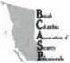

BRITISH COLUMBIA ASSOCIATION  
OF SECURITY PROFESSIONALS

March 28 - 31, 2007 Vancouver Canada

The Best Western Richmond Hotel & Convention Centre

Trade Show and conference program featuring

* Electronic Lock Installation and Service  
* B.C. Building Code

* Basic Electricity and Electronic Locks

And the following ALOA Continuing Education (ACE) classes:

* Comprehensive Safe Lock Servicing
* Servicing Aluminum Storefront Doors
* British Columbia Building Codes
* Professional Picking Techniques
* Automotive Lock Servicing I
* Combination Lock Manipulation 1
* Exit Devices & Exit Alarms
* Professional Impressioning Techniques
* Master keying Methods and Formats I
* Automotive Lock Servicing II
* Combination Lock Manipulation 2
* Keyless Mechanical Lock Servicing
* Master keying Methods and Formats II
* Alternative Entry Techniques
* Basic Auto Transponders Systems

For more information contact us at [www.BCASP.org](http://www.BCASP.org)  
email [tradeshow@bcasp.org](mailto:tradeshow@bcasp.org) or phone 604-850-9359

Keynotes • March 2007

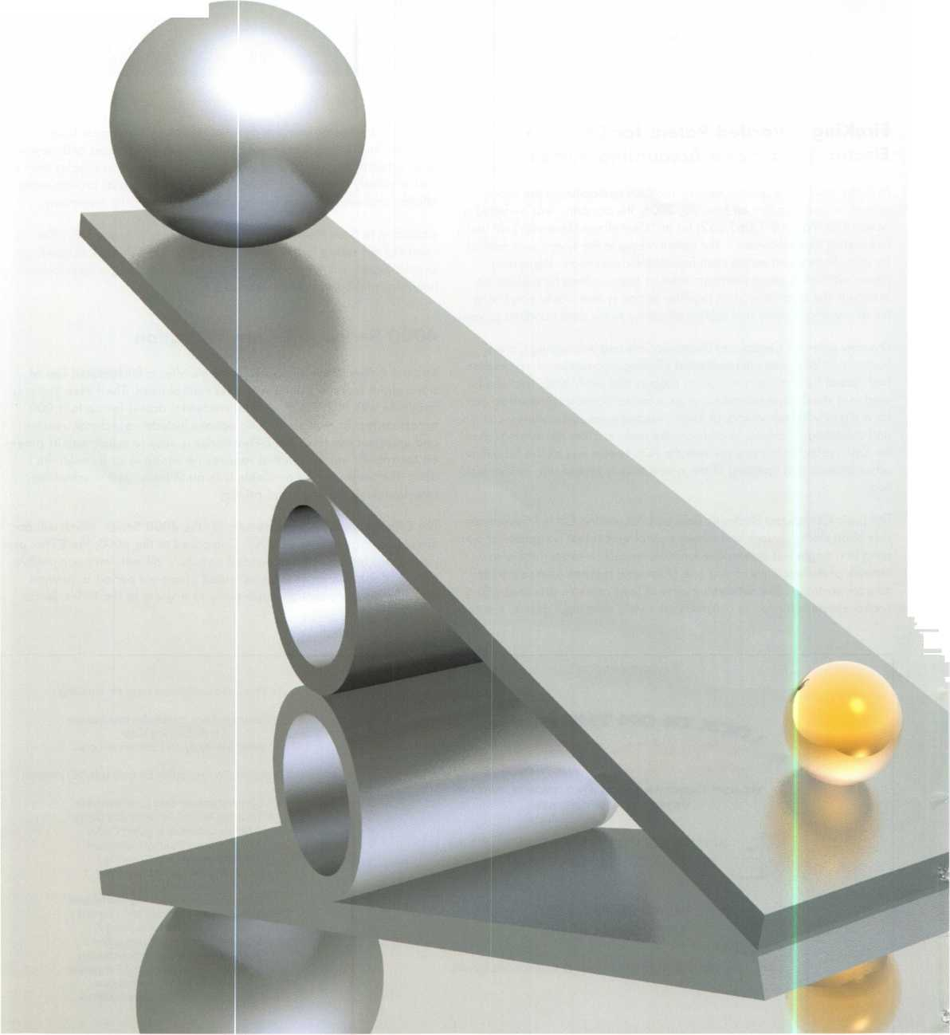

C.D. Lipscomb, CML, CPS, CIL

* Locksmiths Weigh in on ’ Licensing Issues

By C.D. Lipscomb, CML, CPS, CIL and Dan Floeck, Jr

I am a locksmith shop owner in Corsicana, Texas. For the last two years, I have been registered individually and my business has been licensed with the Texas Dept, of Private Security, a branch of the Texas Dept, of Public Safety. In this article, I will try to relate how this licensing has affected me in a practical sense in the time that the law has been in effect. The law in Texas was passed before Texas locksmiths were really aware of it and as a result, there was little or no input from our industry about how the law was written or what was included. In fact, the law was chiefly written by representatives from and for the burglar alarm industry with a minimum of input from our locksmith lobbyist. Because of this lack of locksmith input, there are numerous flaws in this bill that was signed into law before we could affect or challenge it. Nevertheless, I consider it to be a good thing for me and my company.

In talking with my employees and a couple of nearby competitors, I asked what changes they had seen as a result of our law. These are the items mentioned:

We have all raised our prices. At my shop, we went up on our service-call price 20% with no remarkable complaints from our customers. The lack of customer complaint was a shock to me. We raised our hourly rate 15%, again with little complaint and no detectible loss of business. In reaction to higher key prices and licensing costs, we have raised our key-cutting prices to the point that the cheapest key we duplicate is much higher than any other KW1 prices that I have heard of in the state.

We are all making more money. As a result of higher prices, our profits are up and we are busier than ever before with the same number of people working. This seems apply to everybody I have talked to.

We have lost employees because of the background check. I had to lay off a very good employee due to a problem in his back ground. I liked him and regret losing him but I am glad I found out about it. Had his record come to light as a result of any problems, I would have been

Keynotes • March 2007

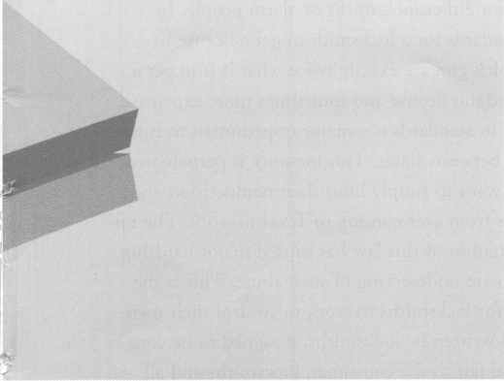

severely embarrassed to have a person with a breaking-and- entering conviction on his record working for me. Now, my hiring procedures have been tightened up.

We have gained standing and respect from our customers. Without exception, the customers that have commented when told of our new law and license have given very favorable responses. Generally, they are dismayed that we have not been licensed before now. Our consumers seem to really like this law even though it means more paperwork for them.

We have had to make our employee records more compre­hensive and professional. This is something that all employers should do but in small locksmith companies, it tends to get shoved to the side and never gets done. Good human resources procedures are a must in todays world and this made me do what I should have done all along.

We have become more professional Today, we tend to be a better company than we were before licensing. Our techni­cians wear their licenses as badges, look more confident, and more professional. We have our license numbers on our trucks, and that feels good. Since we have gotten our license, we are proud of that fact that we have it. We are a part of something more than ourselves.

“Fly by night” competitors have gone away. We have all seen some of the low-quality, uninsured, and untrained people that plague our industry simply disappear when forced to meet the same overhead costs that we have lived with all along. Our company has always been insured and bonded. We go to classes to keep up with our industry and we belong to community and trade organizations. It is nice to see us all playing on the same level field for once.

We have had other competition drop out due to being forced to have the same overhead (insurance, taxes, record keeping, etc. ) — We had one competitor here locally who closed when forced to pay his taxes, buy liability insur­ance, keep business records, give customer receipts, and be accountable to his customers for the work he did. This is immensely satisfying to see “the good guys” win one for a change.

We have an effective agency to complain to about abuses from other unlicensed locksmiths. The law protects the consumer and for once, gives them a place to complain

about abuses in the industry. One of the more infuriating things about service work is to see abuses of the standards of this industry and not have a place to complain. The Texas Department of Public Safety has proven itself to be willing and able to react to consumer complaints. Whether a locksmith writes in about another locksmith, or a con­sumer complains about shoddy or fraudulent work, they do investigate and file cases where justified. People have gone to jail in Texas for flouting the law and cheating their cus­tomers. We have been impressed by our investigator s dedi­cation and fairness. We consider the enforcement in Texas to be outstanding.

We have credibility. For the first time in Texas history, we are more than handymen and tinkerers. We are part of a group of regulated professionals. Prior to this act, the word “locksmith” was not even in the state statutes. Today, lock­smiths have a standing with the state where before we did not exist. We are now a profession whereas before we were simply a trade

Our work is defined and protected. No other industry can legislate us out of the work we have done for so long, wlec- tronic access control, which is rapidly replacing traditional mechanical lockwork was slipping away from us. Today, our future is bright and our place in the world is secure.

The industry lost a lot of our talent due to an unrealistic background check instituted by others rather than lock­smiths. In Texas, we lost about 30 percent of trained tech­nicians due to a background check imposed upon us by the burglar and fire alarm industry. The Texas background standards are exactly twice what they are in any other state in the union for either locksmiths or alarm people. In Texas, the standards for a locksmith to get a license to legally use a pick gun are exactly twice what it is to get a concealed handgun license and four times more expensive. This inequity in standards is a major impediment to future reciprocation between states. This inequity is perpetuated by those that want to simply limit their competition and prevent others from ever coming to Texas to work. The ini­tial implementation of this law has caused major hardship for many who are undeserving of such abuse. This is the major reason for locksmiths to work to control their own destiny. A bill written by locksmiths, designed to be com­prehensive and fair to the consumer, locksmiths and all other parties affected, like the present Oklahoma law is

**12**

Keynotes • March 2007

critical to both the public and our industry.

If locksmiths do not move to support such legislation, then legislation written by and for others and unfair to lock­smiths will overtake them and soon we will cease to exist as an industry. Already, the mechanical locksmith is being crowded out by the diminishing number of mechanical locks to work on. Safetechs are being squeezed by tradi­tional locksmiths fleeing electronics, increasingly technical automotive, and rapidly-diminishing mechanical work. Electronics abound. For those that choose not to embrace electronics, they can look forward to an early retirement. If we are effectively legislated out of the electronic field, then within 5-10 years, there will be less than half of us left in traditional locksmith roles. This is happening in a majority of states in our country now. The world will change with or without us. If we let the Oklahoma law be gutted, or repealed, only alarm people and electricians will be able to service electronic locks and access control. We could cease to exist as an industry in a relatively short time and could all become employees to those industries. As such, the con­sumer will be poorly served.

I urge you all to support with your efforts, your time and your dollars the preservation of the Oklahoma Locksmith licensing law. This law has been described by all that work in locksmith legislation as the best-written law in the coun­try for locksmiths.

Dan Floeck, Jr

I was against licensing for many years. I was worried I might lose some control of my supply company or have to give the state special reports. Additionally, I was concerned my customers would be overburdened with reporting, con­tinuing education and imagined potential problems.

I was somewhat surprised when this law passed Texas. It seemed locksmiths across the state were against the pro­gram when in reality, there was only a small percentage voicing loud opposition to the law. Others went along with that group but were not truly on either side. Once the law went into effect, most all accepted the fact. Now it's diffi­

cult to find the dissatisfied few. Because of the law, we have lost some locksmiths to the auto repair services, construc­tion trade or even to Oklahoma. The number of lock­smiths lost was equal to the small vocal opposition.

I am glad to say, locksmith licensing has not just been well accepted, but a hit in Texas. We no longer worry that felons, drug abusers, child molesters and deadbeat dads could be part of the profession. No longer am I concerned when a new acquaintance tells me he will need a locksmith. The lady that has to open her door to a locksmith does not need to be afraid. We won’t see a sting on television show­ing a disreputable locksmith opening a home without proper customer identification. No longer will a locksmith gouge the consumer. Our Texas 800 reporting number is making sure of that.

Our state and many other states are targets of unethical 800-number locksmith marketing companies accepting calls and dispatching unscrupulous subcontractors to drill and replace locks when they were only called to open a locked door, in some cases charging as much as eight to ten times what a locksmith would have charged. These same marketing companies quote low prices to stranded motorists, do shoddy work and bill the customer many times the original quote. Locksmiths in larger markets once advertised multiple business names in order to confuse the customer. This was done to quote multiple prices, manipu­lating the confused consumer who called the same business several times to accept a higher price. This problem no longer continues in Texas. Although $5 to $10 has been added to the consumer fee, I am convinced the public is much safer than before licensing and is being well served. Licensing is working. I was wrong.

Locksmiths are profitable, better educated (8 hours CE) including ethics training, nsured, and are happier than before licensing. The public has never been better served than they are today. This is a win/win deal your state will embrace when all facts are considered. Locksmith regula­tion makes good sense and you will be proud of your efforts to make it a reality.

**13**

Keynotes • March 2007

MEMBER*

potlight

Welcome to our new monthly feature! Each month we will highlight a current ALOA mem­ber & their lockshop with a short bio and in-depth questions. To be considered or to recom­mend a fellow ALOA member please read the information provided at the end of this article.

teve Cothron, President of Cothron’s Safe and Lock pro­vides complete lock service to the Austin area. They have been a part of the locksmith business for over 60 years and are enthusiastic supporters of the Associated Locksmiths of America.

Cothron’s Safe and Lock 807 E 4th Street 512-472-6273 Austin, Texas 78702

1. Tell us about your background in security and your experience in locksmithing. **Steve:** I started working in the industry full time in 1977 right out of high school. I have worked the counter, been a road tech, dispatched, and worked in payables and receivables. I have a working knowledge of all aspects of the busi­ness as well as the technical side of the business.
2. What is your favorite place to visit in Austin?

**Steve:** My dads house.

1. Why?

**Steve:** Because of his wealth of knowledge, I always pick up something that helps me run the business and better serve our customers.

1. How did you get involved in the business?

**Steve:** When my dad, Olen Cothron, left military service after WWII, he was in the OSS, he made his way to Austin and opened his shop in 1948. As I grew up, I worked in his shop after school and weekends. I went with him on serv­ice calls when possible. After high school, the work became full time and the rest is history as they say.

1. Tell us about the changes you've seen in security technology recently.

**Steve:** It seems to me that the technology has evolved from the simple lock and key protecting against intruders to focusing as much or more on protecting businesses from themselves. In other words, a great deal of time is spent keeping shrinkage in check and monitoring the traffic flow of visitors and employees, etc.

1. Do you find that other locksmiths in the Austin area work together on referrals and workflow?

**Steve:** They do sometimes but I believe it could be better.

1. Can you remember your first big security job? What can you tell us about it?

**Steve:** There are several that come to mind but the one that sticks out the most is the rekeying of Fort Hood in Killeen Texas. Fort Hood is the largest military facility in the free world and we got to know every inch of it. It also sticks out because we had barely begun the project when 9/11 hap­pened. It caused a lot of interesting times getting on and off the facility to complete the job. The project took 2 1/2 years to finish.

1. What has been your most exciting project to date?

**Steve:** We sre currently working on a project with the Texas Department of Transportation. It has the potential to become on of the largest we have ever done and it involves both traditional locksmithing as well as a lot of access con­trol tied to cameras and alarms.

1. What advice can you give to an aspiring security profession­al?

**Steve:** Start out by learning the basics of locksmithing.

Locks and keys will always be an integral part of security. Then get training in Electronic locksmithing, access-control devices, CCTV, OCTV, and alarms. This is the future of our industry.

1. How do you stay informed about new products and security techniques?

**Steve:** First by reading the trade magazines, like **Keynotes.** They are always very informative and the least intrusive on your time. Then, there are the trade shows like the ALOA Convention and Security Expo, along with the classes they offer. Certainly, the manufacturers reps and vendors reps keep us informed as well.

1. How do you sell security to the public?

**Steve:** We utilize an outside-sales force but our best form of advertising and selling security to the public has always been word of mouth. Starting with my dad, we have always felt that if you provide good service with competitive pric­ing, the word will spread. We also use the telephone directo­ry to get our message out.

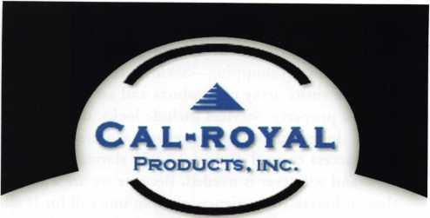

EXPLORER

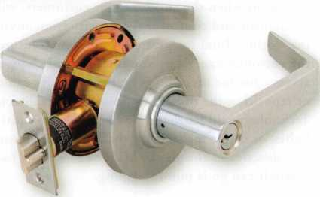

Non Clutch Mechanism, "XP" Series

Fits All Major Manufacturers Thru Bolt Locations

COMMANDER

Clutch Mechanism, "Com" Series  
Large 1C Format

9800 EXIT DEVICES

1

7

Grade 1 Heavy Duty Exit Devices  
Available in all Architectural Finishes



**Cal-Royal Products, Inc.**

**6605 Flotilla Street. City of Commerce, CA 90040 U.S.A.**

**Tel: (323) 888-6601 • (818) 888-6601 • (800) 876-9258  
Fax: (323) 888-6699 • (818) 888-6699 • (800) 222-3316  
E-mail: [sales@cal-royal.com](mailto:sales@cal-royal.com) • Website: [www.cal-royal.com](http://www.cal-royal.com)**

Keynotes • March 2007

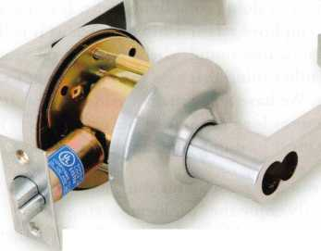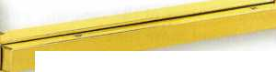

1. What do you see as the future of security? Where are we headed in today’s age of technology?

**Steve:** One stop shopping—Security companies that offer the entire array of products and services to protect life and property. Services include locks, door hardware, doors, door frames, keying, repairs, closers, exit hard­ware, access control devices, CCTV, alarms, security mir­rors, and whatever is needed. Because we are a society that embraces convenience, making one call for it all is where the growth will be. With today’s technology and the promise seen in tomorrow’s, where we are headed is to a point when the end-user, our customers, will be able to monitor and control their security from anywhere in the world—Total integration. I envision a future where the customer can get on the internet and change the access code for their doors or view security cameras and or reposition the camera to point another direction. Technology will let them turn on the air conditioner, lights, or coffee maker with the push of a button that also deactivates the alarm. Most of this exists today, so where it can go is mind boggling.

1. Name one thing in your lockshop that says the most about you.

**Steve:** First, it has to be our employees. They reflect the mood of the company and its leadership. We have peo­ple that have been with us for 20, 30, 40 years which says we must be doing something right. It is not an employee/employer relationship as much as it is like a family. I know that sounds cliche but it is the truth. I think the other thing that says the most about us is our customers. We have many many customers that have been with us as long as some of the employees. This too means we must be doing something that works.

1. What do you like most about your job?

**Steve:** I really enjoy the “problem solving”part

of locksmithing and business ownership. Whether you “fix” a customers problem or help an employee with a personal issue, it is always gratifying.

1. How has life changed for you as a locksmith in the past few years?

**Steve:** Taking the reins of the company as President allows me to spend more time working on the business instead of in it. Although I enjoy the physical work, I also enjoy exploring the possibilities of growth. The other change has been the pressure of having 80 employ­ees and their families relying on my decisions to insure their well-being.

1. Name a few things that locksmith business owners should do to help their businesses prosper and grow.

**Steve:** Invest in their employees. Train them, nurture them, trust them, stand behind them when they make a

decision, council them when they make a mistake. Employees are a company’s biggest asset and investment.

Take care of your customers. They are the reason you exist. Even though their need or concern may sound trivial, it is a big issue to them. Treat them fairly and with respect. NEVER take them for granted.

Stay abreast of the technology in our industry and relat­ed industries. You can not train your employees if you do not know what exists.

You can not properly take care of your customer if you do not have the latest technology to offer them.

Never compromise your principles. We all want more business and to grow and prosper. But if you are trading in your values to do so, it will be a short lived career. Set guidelines to operate by and stick to them.

\17. Give us your biggest locksmithing horror story, toughest job, or the job that taught you the biggest lesson.

**Steve:** With 60 years in business and 80 employees, you would need a lot more room than allowed in this article. Each employee has had their own problems which then become mine.

1. What is the best part of being a locksmith in America today?

**Steve:** I think first it would have to be the public percep­tion of our industry being elevated from where it has been. We are starting to be seen for the professionals we are instead of the tinkerers most saw us as. Also I would say just being able to give people a little peace of mind by helping them secure their lives and property is a big part of being a locksmith. Certainly for years but espe­cially in the post-9/11 era, fear levels have risen regard­ing security, both on a national and local level. The part we play in alleviating those fears is extremely gratifying.

1. Explain the rewards of being an active participant in the profession as a whole, as opposed to someone just spin­ning their wheels trying to make ends meet at a shop.

**Steve:** The rewards are being hands on with people; cus­tomers and employees alike. Our world has become so automated that you rarely get much interaction with a live person anymore. Working with customers and inter­acting with employees is a reward. Setting company and individual goals and achieving those goals is very rewarding. When the company sets a goal and meets it, it means we have worked as a team and pulled together. This is certainly a rewarding feeling. And I guess that seeing the benefits of all the hard work and moving for­ward with the company is rewarding. Knowing how far my dad took it, I have some work to do.



Keynotes • March 2007

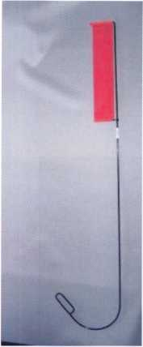

Emergency Door Opening Tools

**AS SEEN AT THE 2006 A.L.O.A CONVENTION**

All commercial buildings have two things in common:

* Fire code requires that all commercial locks open by a single action.
* The American Disability Act requires free access through doorways, which leaves a gap between the door and the floor.

\J

Knoblock Tool

Leverlock Tool

WITH THIS IN MIND WE HAVE DEVELOPED THE TOOLS REQUIRED TO EFFECTIVELY  
OPEN DOORS QUICKLY AND WITHOUT DAMAGE

Designed for interior commercial doors

For knoblocks, the tool is slid under the door with no cords to pull or get tangled.

For leverlocks, a similar tool is used by applying the same method of sliding the tool under the door and pull until the lever retracts.

Both tools are designed to work with very little effort, excessive force is not needed.

Visit our web site at [WWW.THEBEN-JIM.COM](http://WWW.THEBEN-JIM.COM) for more details.

THE BEN-JIM KNOBLOCK TOOL $ 99.00

THE BEN-JIM LEVERLOCK TOOL $ 79.00

SET (one each) $169.00

PLUS SHIPPING & HANDLING

**TO PLACE AN ORDER CALL 1-586-778-1911 OR VISIT US AT [WWW.THEBEN-JIM.COM](http://WWW.THEBEN-JIM.COM)**

MADE IN THE U.S.A BY THE BEN-JIM CORPORATION.

24711 Harper Ave. * St. Clair Shores * MI * 48080 * (Fax) 586-778-0530

Stop Ignoring Your Customer:

Six Expert Techniques to Building Customer Rapport

By: Laurie Brown



Here is a question for all of you. As a customer, how many of you have had a bad customer service experi­ence? Hmmmm. Looks like it's all of you. So think about it, if all of you have had a bad experience, it means that most likely all of your customers have had one too.

If your customers have had a bad experience, then consciously or unconsciously, they are affected by it. Have you ever noticed that some customers come in with an attitude — a chip on their shoulder or an emotional wall up? In these situations, when your cus­tomers are on the offense, like so many other service providers, you end up feeling defensive. But, it isn't necessarily about you. It is based on another experi­ence with another person they have dealt with. So what can you do to remove the chip and break down the wall?

**18**

Keynotes • March 2007

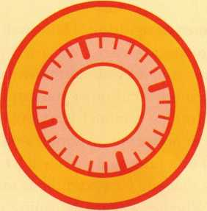

**BRIGHTEN** YOUR  
FUTURE. **HIGHLIGHT**YOUR SUCCESS!

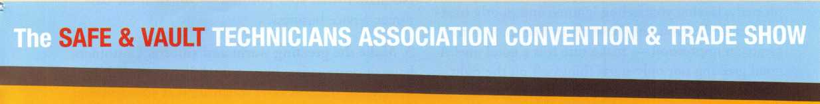

2008

CALIFORNIA

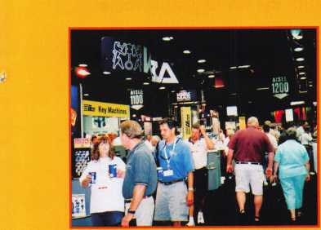

Highlight your path to the future with the latest technolo­gy the industry has to offer to safe technicians at SAFETECH 2008. Exposure to today’s top safe distributors and manufac­turers is absolutely crucial to making good purchasing and sales decisions. Additionally, time is of the essence when it comes to education. New developments spring up each year, making top-notch safe

classes a necessity in our ever-changing environment. SAFETECH classes cover subjects related to the installa­tion, maintenance and opera­tion of sales and vaults at lev­els from novice to expert. The only chance to get world-class education and meet with the industry’s top distributors and manufacturers is at the 2008 Safe & Vault Technicians Convention & Trade Show.

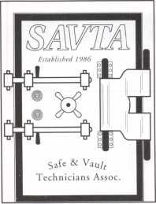

**SAFETECH 2008**

**March 31 -April 5, 2008  
Bahia Resort Hotel  
San Diego, California**

**[www.savta.org](http://www.savta.org) • 214.819.9771**

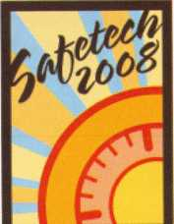

SAN DIEGO

CALIFORNIA

Greet your customers warmly and sincerely. A truly warm welcome can be totally disarming. Imagine walking into a restaurant and being greeted as a friend or member of the family— someone who was grateful to have you walk in to their place. No matter how good the meal was, you would still be happy you went there. The experience would have been positive enough that you would gladly give them another try.

Even though greeting your customer sounds so basic, aren't you amazed at how often people fail to do this properly, leaving you feeling ignored and poorly treat­ed? Remember you only have about five seconds to create an impression — make sure it is a good one! A good greeting not only starts things off on the right foot, it can also build a strong foundation for the future.

So, what are the elements of a good greeting?

1. Do an attitude check. Before you start your work­day, do a personal inventory. How you are feeling? Are you tense? Are you rested? Did you just have a frus­trating drive in to work? Did you have an argument with someone? Be aware of how you are feeling and what you are thinking, and leave any negative emo­tions at the door. You’ll find it is too hard to automat­ically treat others well when you are battling with your own problems.

1. Immediate customer recognition. Don't wait even a couple of minutes to acknowledge your guest’s pres­ence. If you are in proximity of your customer, say hello. If you are with another customer you can still acknowledge them. Nothing is more frustrating than waiting for someone to notice you. A simple nod of the head, eye contact or a brief comment will let the person waiting know that you have seen them and will soon be with them. Whether you are the janitor or the CEO, say hello to the customer as soon as you can.

No matter what your position — you’re in the cus­tomer service business.

1. Make the greeting warm and sincere. Customers have sincerity radar. They can tell if you are “faking it.” One of the best ways to ensure that your greeting is warm and sincere is by expressing your gratitude. If you are not truly grateful that this person chose your establishment, you need to remember where your pay- check is REALLY coming from. The more that you can feel appreciative that this person has decided to do business with you, the better you will treat them.
2. Handshakes are optional. It is usually standard practice to make sure that EVERYONE gets a hand­shake, but the fact is, there are many cultures that find a handshake offensive. With the world getting more culturally diverse, the best tip is to wait with your hands at your side until the customer makes the first move and then respond by doing what they do, whether it’s a handshake, a hug or a bow.

V

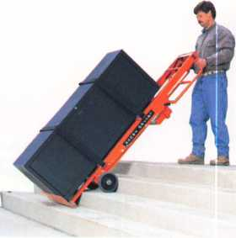

*Lectrd'Truck*

| STAIR CLIMBINGl SYSTEM

Visit us online at:

[www.lectrotruck.com](http://www.lectrotruck.com)

...or call us today at:

800-619-0625

The Lectro-Truck will make it easier for you to break back a load, climb and descend steps, and even load onto your truck or trailer!

Save on damage costs.

Save on injury costs.

Save on labor costs.

The bottom line: You save money!!

The Lectro-Truck makes this all possible - all while having a 1500 # capacity!! Call us today to find out what you have been missing.



Keynotes • March 2007

1. Avoid asking, ”How may I help you?" In a sales sit­uation, this question allows the customer to say, "just looking," at which point you are already at a disadvan­tage. It’s better to start off with, "How are you?” or a compliment on something they are wearing, such as, "great glasses, where did you get them?” or even a com­ment on the weather. Conversations like these can often help you start building rapport. But if your customer doesn't like small talk get to the point quickly.
2. Understand your customer. Begin your relationship with the true goal of finding out their wants and needs and then try to make sure that you fulfill them.

Working with this goal foremost in your mind will help define every action you take.

No matter what your business, your customer has needs that are spoken and unspoken. This means that you need to listen carefully Listen with your ears, eyes, heart and mind. Listen to the words they are saying, observe their body language, listen to their tone to understand the emotional content, and be aware of what is not

being said. Effective listening will help you deeply understand your customer. If your goal is to meet and exceed their needs, you can create a loyal customer who will tell their friends and family about you and your business.

Following these six steps will help you start building greater rapport and trust with your customers. The sooner you build rapport and trust, the sooner you can remove that chip from their shoulder or start tearing down their wall and create a "customer for life."H

About the Author:

Laurie Brown is an international speaker, trainer and consultant who ideas help people improve their sales, service and presentation skills. She is the author of The Teleprompter Manual, for Executives, Politicians, Broadcasters and Speakers. Laurie can be contacted through [www.thediffer- ence.net](http://www.thediffer-ence.net), or 1-877.999.3433, or at [lauriebrown@thedifference.net](mailto:lauriebrown@thedifference.net)

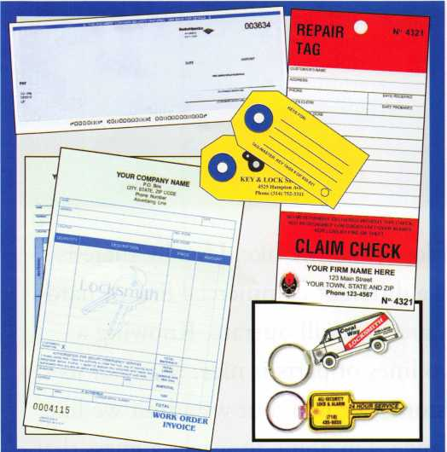

**Professional Business Products**

Invoices Tags *Call for a free*

Checks Key Fobs *brochure and samples*

**Business Magnets** 1**-**800**-**355-6322

Cards Labels [www.pbp2000.com](http://www.pbp2000.com)

You need it When?

**How about now!? :-)**



Another Special  
Value-added Benefit to your

ALOA Membership!  
Click here

**i**L

[www.clearstar.com/ALOA](http://www.clearstar.com/ALOA)

Keynotes • March 2007

Something Old, Something Hew, Something Borrowed, Something Blue

By Greg Perry, CML, CPS



Most of us seem married to a brand or two of locks that we like. Usually there is one favored major residential line and perhaps a different commercial line of hard­ware. We like the familiar and to know how a product will operate. Knowing a partclar brand’s quirks and stocking one or two lines of parts is nice. Many of us keep pieces of the other brands to satisfy a customer or two, but we admit we like to sell the familiar. Perhaps it is difficult to change. I’m going to wager a guess that most of you didn’t jump on electronic-push-button locks when they first came out. It took awhile before you finally accepted them.

Keynotes • March 2007

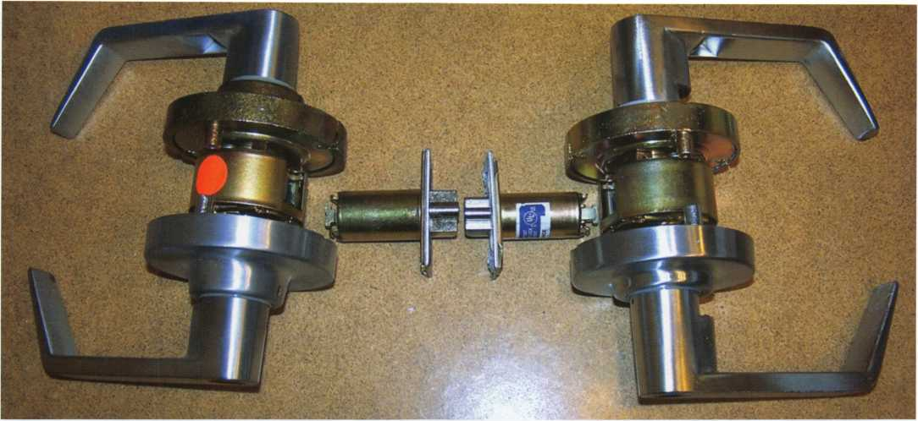

Photo 1 shows 2 Survivor series locks. On the left is a Grade 1 model 195AB lock, on the right is the Grade 2 170AB. The smaller latch bolt can

be seen in the photo.

When our commercial lever lock brand changed design, we decided it was time for us to consider a change. Marks USA has been producing quality hardware in Amittyville, NY for several years. After hav­ing good success with their IQ line of elec­tronic-push-button locks, we decided to change our commercial levers to Marks products. The “something old” from the title of this article refers to their Survivor series of locks. “Something new” is their new imported grade-2 low-price lever lock, something borrowed is in their new Hi- Security line. “Something blue” is their packaging. We’ll take a detailed look at the levers first and then a little at Hi-Security cylinders, following up with a detailed cylinder article in a future issue of Keynotes.

Marks USA produces three grades of levers: Grade 1 series 95, Grade 2, plus the 70 series. These locks will provide many years of trouble-free service. Marks USA is so sure of the quality that they offer a limited lifetime warranty. Out of a few hundred we’ve installed we’ve only had one button pop out and once, a screw was missing from a new spring cage. Both options offer a 3-hour fire rating and “the Clutch”. The

IN-STOCK...MORE SAFES

*FREE Freight Program*

*(30* ***States)***

AMSEC FireKhg fiartall HAYMAN MEIUNK yiCTOn

TURD ID

**WHOLESALE SERVICE**

800**-**848-9790

Keynotes • March 2007

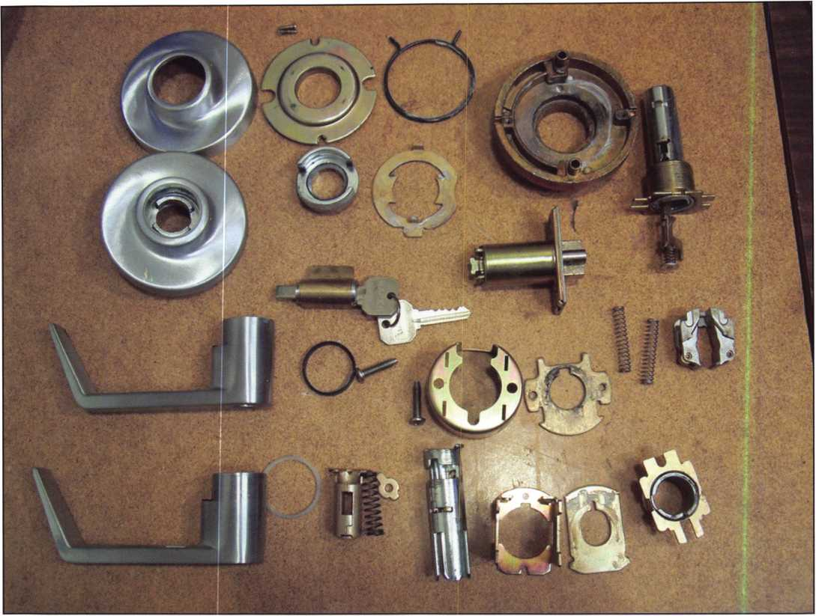

Photo 2 is the 195AB disassembled. However, with the lifetime warranty, you will probably never need to disassemble the lock this far.

differences between these lock series are: the size of the rose  
and the length of the latch throw. The 70 series is 1/2”

throw available in both 2 3/4 (standard) and 2

3/8” backsets. The 95 series is only avail-  
able in a 2 3/4” backset with a 9/16”

throw. The size of the bolt is also  
larger than the 70 series latch.

Also available for 95 series is a  
3/4” throw anti-friction-type  
latch and backset extenders to  
convert a 2 3/4 latch to 3 3/4”  
or 5” backset. Although it will  
not maintain the same rating, the

latches are interchangeable between  
all three series of locks. The clutch is  
the best part of these locks. To be

honest, I felt our customers would Photo 3 is the back side of the spring cage with the back  
not like this feature and it actually cover removed,

kept us from looking at these

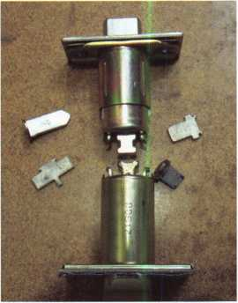

Photo 4: Two different spring latch-  
es. On the bottom is the passage  
version. On the top is the privacy  
latch with a different T-shaped  
retractor. Also included are 4 of the  
many tailpieces available from  
Marks USA

Keynotes • March 2007

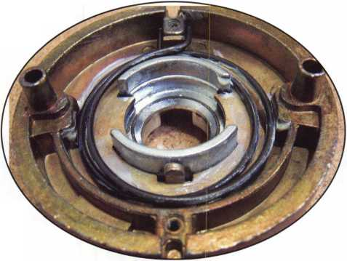

**How Can a Simple Little Box**

**Deliver So Much?**

120 Glasgow Avenue, Inglewood, CA 90301 U.S.A. T: 310-645-0023 1-800-826-7493 F: 310-641 -1586 E-mail: [info@doorking.com](mailto:info@doorking.com) [www.doorking.com](http://www.doorking.com)

The DKS 1838 is a two-door controller that is much more than that.

For starters, it easily expands to control up to  
16 doors. Reporting capabilities are included,  
which makes the DKS 1838 ideal for small  
businesses, office buildings, factories,  
industrial sites, apartment complexes,  
condominiums, gated communities...

And more:

* elevator option to control 4 elevators  
  serving up to 64 floors each, with  
  floor access restrictions built-in
* anti-pass back for complete control  
  into, and out of, secured areas
* live transactions - view activity  
  in real time on your computer
* interfaces with card readers,

RF controls, keypads, etc.

* access control for up to  
  3000 users

And that’s not all.

Call today and let us show you how DKS can simplify your life.

DoorKing telephone entry systems have always been our preferred systems, because they can fit any application we Ve ever run across - small and simple to large and complex.5

*Rich Gonzales* Vice President

Mid Atlantic Entry Systems LLC Abingdon MD

Card Readers Keypads RF Controls

Member: AFA. DASMA, IDA, NOMMA, SIA, SSA

ACCESS CONTROL SOLUTIONS

for over fifty years

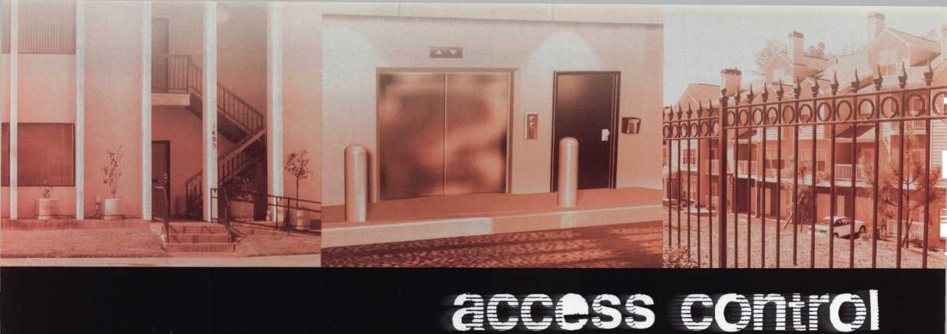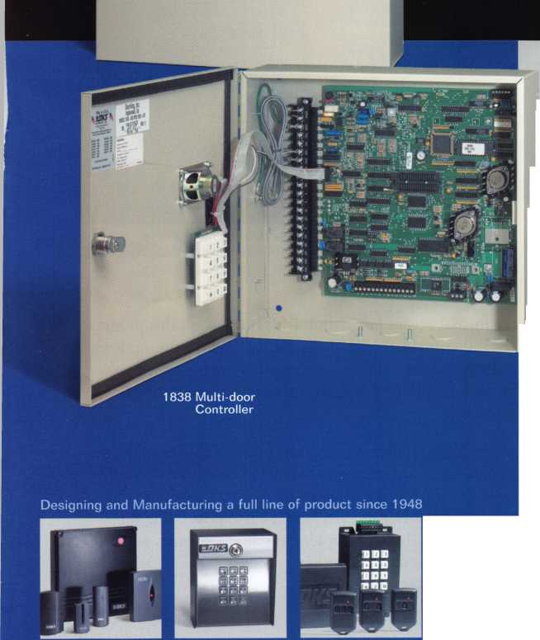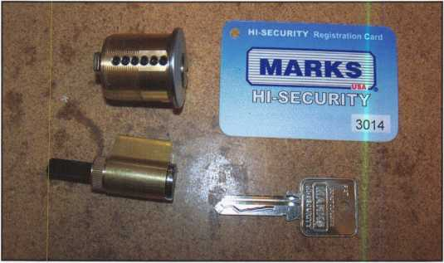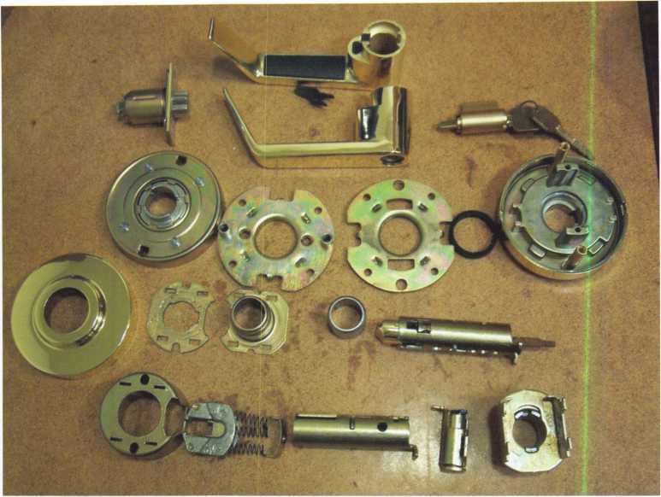

locks at first. The clutch  
allows the lock system to work  
in reverse. When the lock is  
unlocked, the clutch system  
engages (or locks) the lever to  
the chassis. Locking it disen-  
gages the lever from the chas-  
sis and allows the lever to  
“clutch” or move freely. Our  
customers like the design. It  
prevents damage or entry  
though the door by clutching  
instead of failing. The chassis  
are the same between both of  
these locks. The difference is  
in the rose size and the latch.

Rounding out the line of  
Marks USA lever locks is a rel-  
atively new lock—a true  
Grade 2 lock, the 1150 series  
lock. It was added to the  
Marks USA lineup to compete  
against other imported locks.

This lock is great for interior

doors or exterior doors with deadbolts not needing the  
clutch system. The spring cages have a slightly different  
design. The other thing to mention is this lock carries a  
5-year warranty which a good long time but nowhere  
near as good as the lifetime offered on the Survivor Series  
locks. This lock very easily fills a need in the market for a  
quality lock at a reasonable price of around $120.00.

Talk to your distributor to find out the nice  
discounts available.

Photo 5 shows the new 1150 disassembled. The spring cage for this lock is sealed. The tailpiece for  
this lock is smaller than the Survivor series.

A couple of observations about Marks USA levers: First, they have a variety of tailpieces depending on function. Second, they offer a variety of tailpieces for use on other brands of cylinders. Third, since they share the same chas­sis, both of the Survivor series levers require a spacer for use on a 1 3/8” thick door. Fourth, they use the same hole prep for the thru-bolts as many other popular locks. Fifth, privacy and passage locks use different latches because of the need to restore (or pop out) the button on the privacy when the door is shut but all their latches interchange between different grades of locks. They require a few extra parts, meaning there’s a little more inventory but these parts are relatively low in cost.

The newest product from Marks USA is their Hi-Security lock cylinder. Although it was not developed in reaction to

Photo 6 shows two of the new Hi-Security cylinders.

The milling on the side of the key is for the finger pins that engage the

sidebar.

the media’s recent fascination with bump keys this product certainly provide a high degree of resistance to bump keys, picking and even drilling at a very reasonable cost. Look for an in-depth article about them in a future issue of Keynotes.

Marks USA produce some great products that have become a good match for our company. They also produce a huge line of mortise locks, ornamental iron locks, tubular locks, cylindrical knobs and even have a custom lock line for unique needs. If you’re looking for a new partner, you might want to check them out.

**26**

Keynotes • March 2007



ALOA

Don't miss the ALOA

• . • • • •

Opeiji.Golf Tournament

£S&TJuly 26, 2007!

Held during the ALOA Convention and

• •

Security Expo, this is a great .event, **^**

for friends, food an.d.sonn%dncTaz\^^A

• , *. .

ing networking opport8mties!s^^;^^j

* ** *■ *^*-^**ii>

Register early **to.ertiure^plc^c\j** grouping preferences.

r * •, v •' >i

want to move tast betorrwfevy**. A

* *4 * ••**?•> f **.

reach the 144-player' cut **crff.'V...** . As always, proceeds from- • the tournament will benefit *

the ALOA Scholarship **v ;r**

Foundation. Use the **convdngy#** tion registration form, foujind **QU£ ^** •

online and in the ALOA ft* #1• « Convention and Security Expo brochure to.save yt>ur Ipot todayP

This year, the popular ALOA Golf Tournament will be held at the area's finest daily-fee golf course, the 1 8-hole Arnold Palmer-designed championship golf course at Birkdale in

Huntersville, NC. Voted the "Best New Golf

Course in North Carolina " and one of the "Top Five Public Courses in the State," this excep­tional course features facilities that range well beyond the 7,013-yard layout of golf holes.

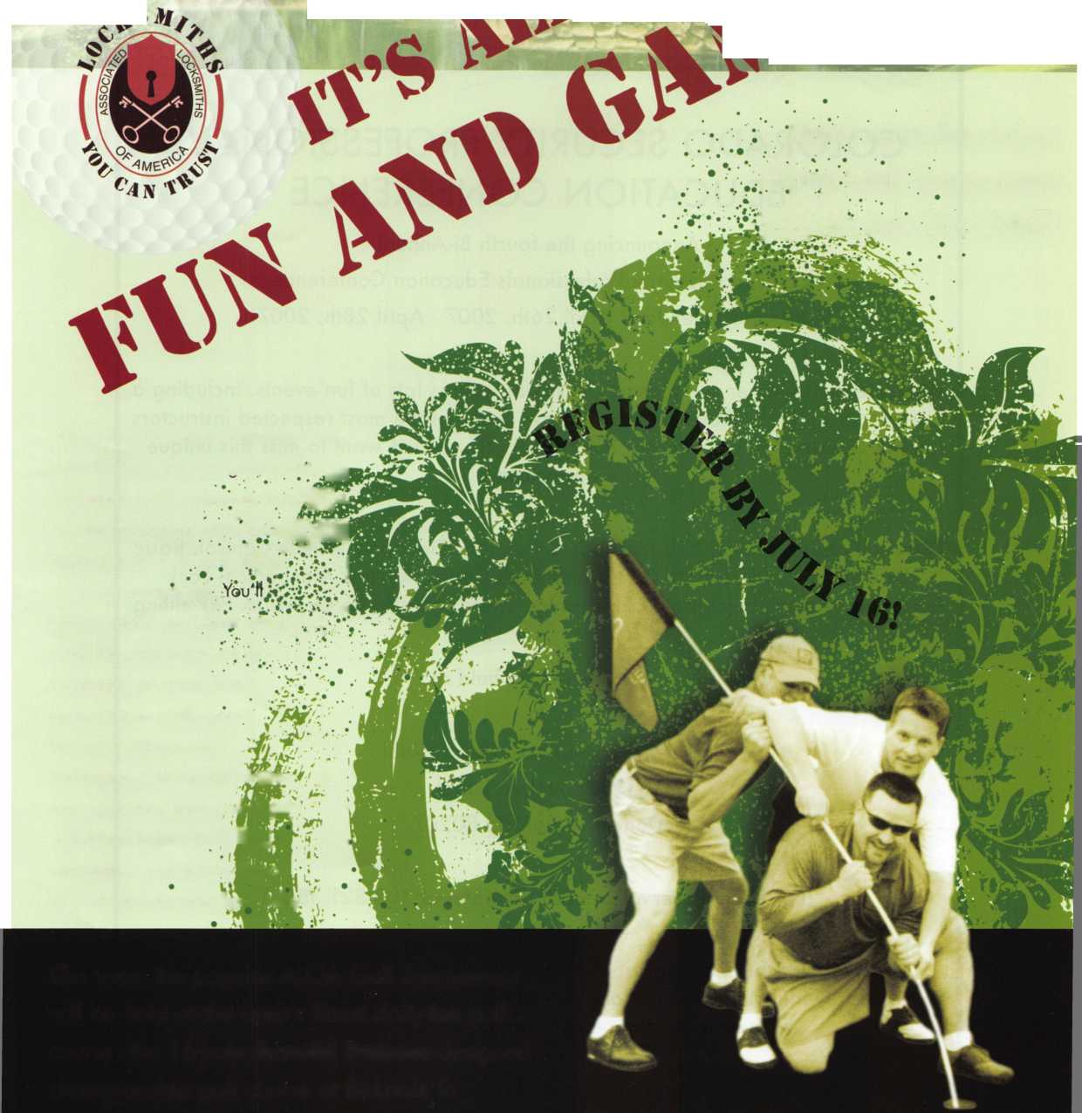

COLORADO SECURITY PROFESSIONALS  
EDUCATION CONFERENCE

Announcing the fourth Bi-Annual  
Colorado Security Professionals Education Conference.

Mark your calendars, April 26th, 2007 - April 28th, 20071!

We have put together some great classes as well as lots of fun events. Including a  
free dinner buffet and evening trade show. Some of the most respected instructors  
in the industry will be teaching our classes. You don't want to miss this unique

opportunity.

Learn all about. Master Key Methods & Formats, Electronic Access Control, Basic  
Locksmithing, Life Safety Codes and ADA Codes, Keyless Mechanical Lock  
Servicing, & Basic Electricity & Electronics. There will also be an ALOA PRP sitting

Classes will be held at:

Radisson Stapleton Plaza Hotel  
3333 Quebec Street  
Denver, Colorado 80207

(For Hotel Reservations call the hotel at 303.321.3500)

For online Conference registration or to download a registration form go to  
[www.securityeducationweekend.org](http://www.securityeducationweekend.org) or call: 303.688.4104 Or go to the website:  
[www.radisson.com/SecurityEducationWeekend](http://www.radisson.com/SecurityEducationWeekend)

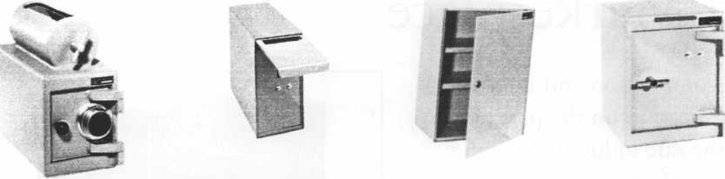

A & B Safe Corporation

Manufacturers of Quality Depository Safes & Chests

114 South Delsea Dr. Suite 3 Glassboro, NJ 08028

800-253-1267 Fax 856-863-1208

[info@a-bsafecorp.com](mailto:info@a-bsafecorp.com)

www. a-bsafecorp. com

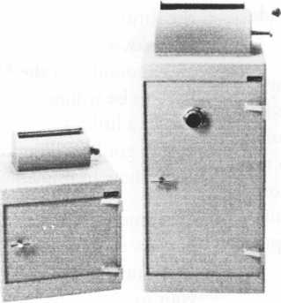

Over Seventy-Five Models In Stock

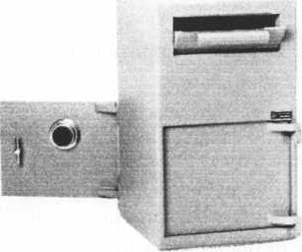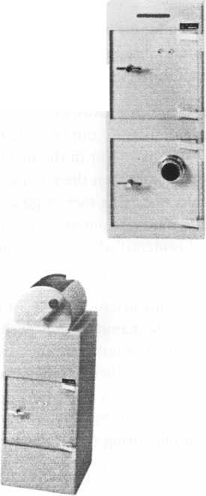

Understanding Innovation in the Global Marketplace

Intense global competition and increased technical sophistication on the part of the consumers in the safe industry drive the demand that manufacturers constantly innovate; and by innovate, we mean the ability of its designers, engineers, and staff to develop and bring the right products and services to market quickly.

More than simply invention however, innovation is first and foremost knowledge in the form of new ideas, new business processes, and new employee skills. It is what enables companies, particularly manu­facturing firms in the safe industry, to respond quickly to rapidly changing market conditions.

Innovation is not an end unto itself - it is an invest­ment of many resources whose economic objective is to add value to both a business and its customers.

Innovation Drives Economic Growth

The process of innovation is also not the reactive result of random events that occur in the marketplace. Typically, innovation begins when there is a need in the marketplace that is not being met. A good source for determining those needs is your existing cus­tomers. Once a need is identified, you must decide how best to come up with a solution.

As manufacturers, we don’t invent a whole lot in a vacuum. In the past, some manufacturers pushed out products hoping consumers would buy them, some­times this proved successful, other times, not so much. At any rate, today’s customers are now much more actively involved in suggesting (or demanding) new directions for the manufacturing companies to pursue.

A current customer of FireKing Security Group approached us and said “wouldn’t it be great if we had a different mechanical override for our safe?” After several meetings with the client, our engineers went to

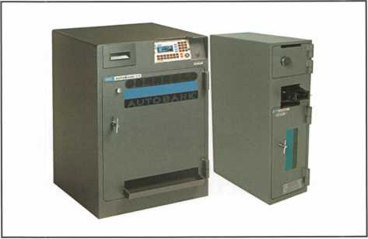

work on a prototype of the product, which currently has a patent pending.

This is typically how we approach the innovative process at the product level.

More than simply developing technology, a relation­ship is created. By using this collaborative approach, we not only solve an existing problem, we also benefit by adding to our product offerings. In turn, we con­tribute more to the industry and to the economy as a whole, and remain competitive in the global market.

Overcoming Barriers to Innovation

Not all innovations are successes. Ideas are great - but every new idea poses challenges. One must pick and choose carefully - your choices will inevitably guide the future of your firm. According to Michael Osofsky, a consultant with Accelovation Management and a founder of the MIT Innovation Club, “you have to be willing to free your mind of constraints, to dream a little. But to actually get something done, you’ve got be willing to look at data and be realistic about how to implement a dream.”

Customer acceptance and resources can be significant barriers to innovation. Most inventions take longer than anticipated, and the cost is usually higher than your original budget. Time is also a factor. A gap exists between when an idea is created and when the technol­ogy is implemented. There are always only a certain number of early adopters for any new technology.

**30**

Keynotes • March 2007



**WE ARE LISTENING TO YOUR NEEDS!**

**GET READY. CHANGE IS**

**AROUND THE CORNER!**

Take a LOOK at some of the new things ALOA has planned for YOU in 2007.

ALOA is excited about the new changes in-store for everyone in 2007. For this membership cam­paign we have listened to the membership and are rapidly making changes to suit your needs.

• Don’t miss out as we roll out our new & improved Keynotes magazine introducing such interactive features as a Q&A section exclusively for members.

• More user-friendly ALOA website.

More training & education opportunities.

Better and broader networking possibilities.

ALOA store with more books plus NEW products that help YOUR bottom line.

ALOA offers you the strength of over 8,000 leading  
firms & individuals. ALOA is YOUR voice in the  
industry. ALOA represents the collective interests  
of the association to the press, government, and the  
public. ALOA is able to open many doors needed for  
your success in our ever-changing industry.

CONTACT:

Associated Locksmiths of America 3500 Easy Street Dallas, TX 75247

Phone 800-532-2562 • Fax 214-819-9736

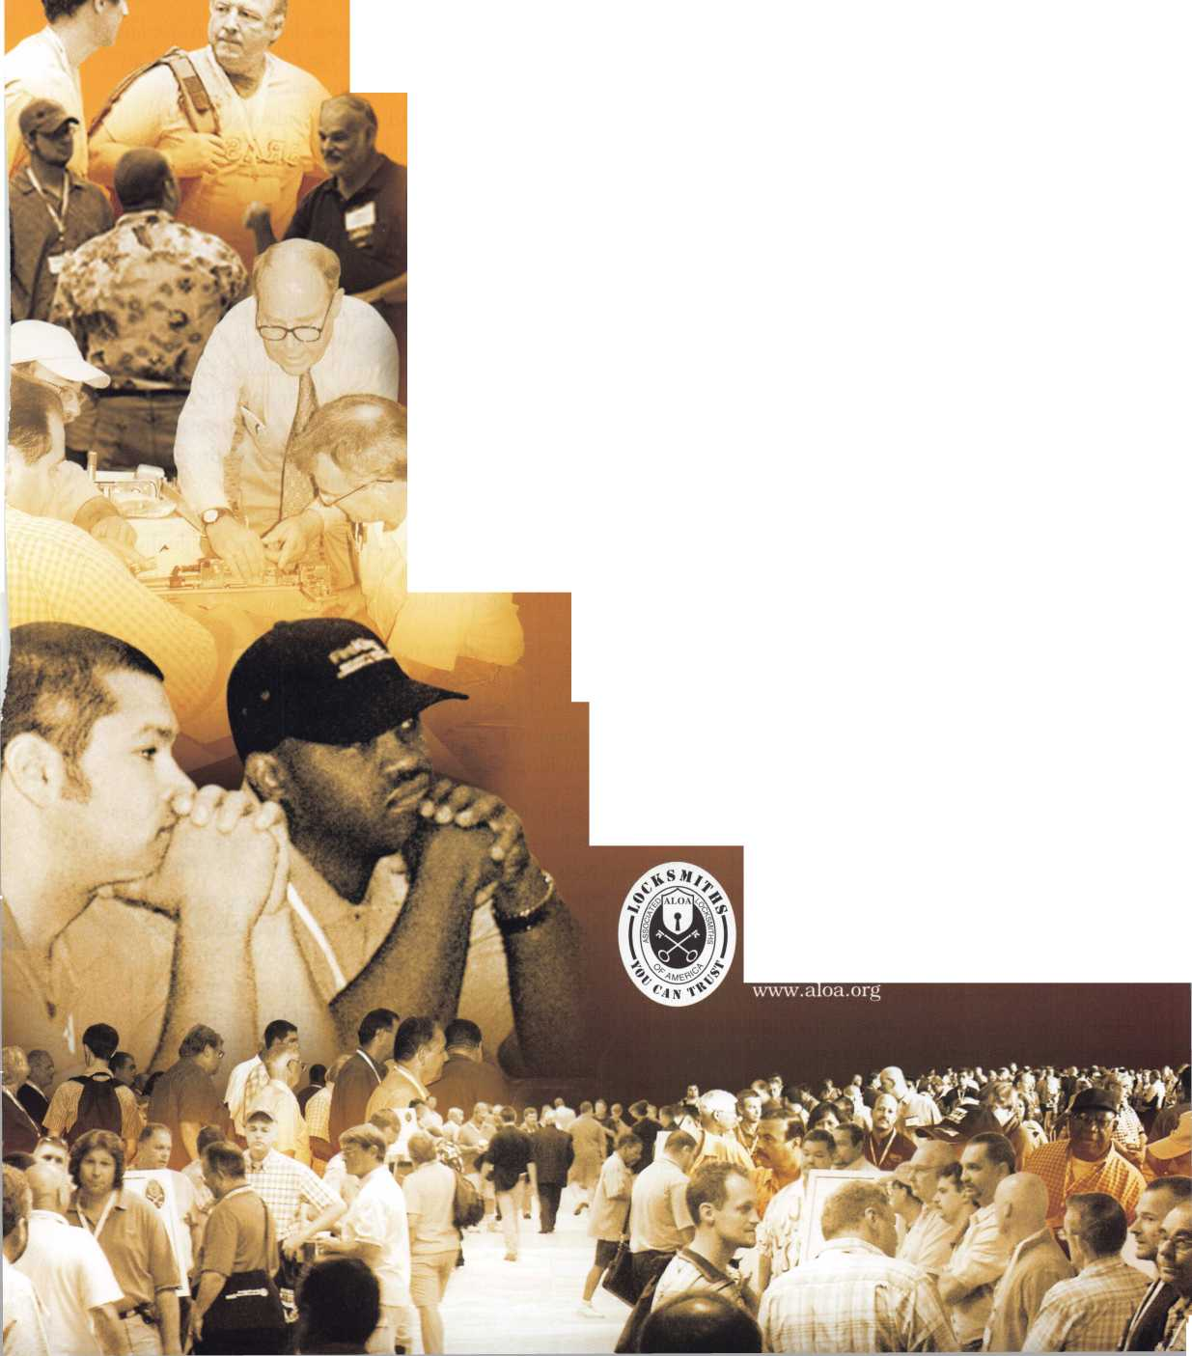

One can invest a great deal of time and resources into innovation, only to find customers saying “that’s great, but were just not sure that we want to do that right now.” Therefore, it is imperative that CEOs and com­pany management must be heavily involved - from the start - in developing a viable business case for new products and identifying needs and priorities in the marketplace.

Creating a Culture of Change

Innovation would not be possible without a corporate culture that welcomes and even thrives on change. To attain this mindset, you have to begin by attracting the right people - lateral thinkers who are able to look at situations from a new perspective without precon­ceptions, in other words, people who think “outside the box.” Over time, this philosophy becomes a part of the overall culture of your organization. Corporate leadership must also willing to look outside of your own company at times for skill sets that may not be traditionally part of your current core competencies. Acquisitions and joint ventures can be valuable sources of both additional products and expertise.

Innovation Involves Risk

Some manufacturers just pour money and resources into R&D in an attempt to “become” innovative, instead of working to understand their clients’ needs and using that understanding to help drive innova­tion. By contrast, only 2-3% of FireKing’s annual sales are devoted to R&D. We tend to be more of an appli­cation driven company as opposed to a pure R&D company. For the past several years, 30-30% of our volume comes from products less than five years old. Customers supply the needs or problems, and we pro­vide the solutions. According to The Economist mag­azine, "Any enterprise that fails to replace 10 percent of its revenue stream annually is likely to be out of business in five years."

In the 1980’s, the security industry was traditionally made up of two types of safes: impact and non-impact rated safes. Impact-rated units were fire resistant and also had been tested for impact (either falling or having something fall on them). Non-impact units were less expensive and easier to get through the supply chain. They also represented about 85% of FireKing’s sales.

We began to explore the possibility of making an impact-rated unit for the same price as the non­impact rated unit. In doing so, we had to examine the consequences of phasing out a product that produced a large amount of revenue for the company.

After careful consideration, we decided to move ahead with our idea. About a year later, we introduced an impact-rated safe for the same price as our non­impact rated unit, and offered wide distribution instead of a special order.

The results were extremely favorable. We eventually replaced all of the non-impact units with the newer design, increased market share, and went from being number four in the world market to number one. Today, this is still our number one product. More recently, the company was awarded a patent (U.S. Patent # 7,063,252) for its “Centralized Electronic Safe and Accounting Control System.” The patent relates to the system and method for cost-effective and secure cash handling for merchants and provides a method for merchants to collect, process and verify cash, and can be used in a stand-alone operation, or as a central control and reporting unit for a digitally linked network of interconnected safes and currency counting and validating machines.

The system allows retailers to place electronic safes at cash registers throughout the store. The safes are net­worked together as one system. This simplifies the accounting process and adds efficiency to the cash handling process.

Technology alone is not a guarantee of success. Great technology and design is of course important but it goes much deeper than that. The culture of innova­tion should be embraced and inculcated throughout the entire company, not just product R&D. When the commitment is made to enable and promote an inno­vative culture, the likelihood of success increases dra­matically. These examples highlight that the true bot­tom line is that innovation - in the form of knowledge and the flow of knowledge - will be the new bench­mark for industry growth in the future. U

Keynotes • March 2007

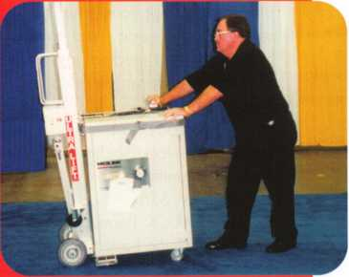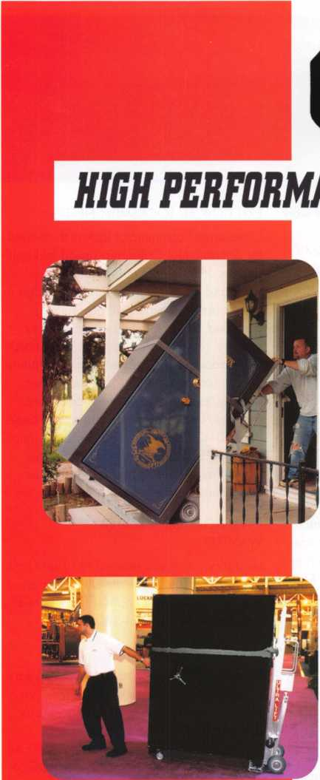

***OPERATOR SAFETY***

Injuries can be virtually eliminated. Ultra Lift does the lift­ing so that operator effort required to complete a move is minimized. Heavy loads are broken back with ease. The operator stays in control by using a combination of motor power, balance and leverage in every phase of a move.

***REDUCE LABOR COSTS***

Fewer people are required for any move with Ultra Lift. Manpower can be scheduled more productively. Labor savings often pay for the Ultra Lift in one month.

***ELIMINATE DAMAGE***

Loads are broken back, set down and moved under power with maximum leverage and operator control. Gentle handling eliminates bumps, bounces and damage to the load and premises.

***INCREASE PROFITS***

Increased operator safety, reduced labor cost and elimina­tion of damage to the load and premises all contribute to significant increases in profits.

FOR LITERATURE, VIDEO OR ON-SITE DEMONSTRATION, WRITE OR CALL:

ULTRA LIFT CORPORATION

475 STOCKTON AVENUE, UNIT E SAN JOSE, CA 95126 800-346-3057 408-287-9400 FAX 408-297-1199

ULTRA LIFT supplies the power - so you don't have to. One person can safely and easily handle loads that usually require 2 or 3 people, even up or down stairs. Two people can handle most safes to 1500 pounds. If safety is your concern, ULTRA LIFT is the best move you’ll ever make!

E-mail: [info@uitraIift.com](mailto:info@uitraIift.com) [www.ultraiift.com](http://www.ultraiift.com)

U.S. PATENT 4,570.953

**Classifieds**

EMPLOYMENT

EMPLOYMENT OPPORTUNITY

Welcome to fabulous Las Vegas! The City of Excitement and Opportunity. Liberty Lock & Safe is looking for experienced and entry-level locksmiths. Our team of 55 dedi­cated Security Professionals provides the services of CCTV, Access Control,

Hardware Installation and residential com­mercial and safe services in this great city. We are looking for motivated individuals for our Road Service Department and our Front Counter Department. Top pay for peak performers. If you have the skills, we have the work. Benefits include paid vaca­tions, generous commission plan, medical and dental insurance. We provide the com­pany van, you supply your tools. We have regular manufacturer's in-house training seminars and an excellent support staff to help you be all you can be. If you are an apprentice, our company can hone your skills and turn you into a superstar in mini­mal time! All we require from you is ambi­tion and drive. Applicants must possess a good driving record, be people oriented, have a neat appearance and pass a back­ground check. Call today 702-871-KEYS, ext 2224 for more information on this exciting opportunity. Email your resume to [james@libertylock.com](mailto:james@libertylock.com) or fax to 702-876- 5470.

WORK WITH US

My name is George Klein. I am a 3rd gen­eration locksmith and became owner of John Koons Locksmiths in 1979. The follow­ing employees and the year in which they started working with me at Koons Locksmiths:

Gino 1979, Beth 1979, Jim 1986, David 1986, Steve 1993, Kirk 1993, Don 1995, Lew 2002, Lew Jr. 2003, Mark 2003, Josh

1. Scott 2005, Mike 2005, Kevin
2. Jeff 2006, Alison 2006. If you are an experienced locksmith and want to join

us working inside one of our shops or work outside services, please call 1-800-282-8458 or fax a resume to 239- 939-5869. John Koons Locksmiths/Fort Myers, Florida.

EMPLOYMENT

San Diego Locksmith and Access Control Company has openings for Locksmiths and Access Control Techs! Grah Safe and Lock is a full service security company that does primarily commercial, industrial and gov­ernment work. Master Key Systems, Safe work and Access Control are areas that we keep full schedule. If you know of a hard­working, customer friendly technicians, who works now in, or would like to grow into this type of work, have them contact us. Positions to work alone, or as a trainee working with an experienced Locksmith or Safe Tech available. Paying $30K to $60K to start, depending on experience and abil­ity. Visit us online at

[www.grahsecurity.com](http://www.grahsecurity.com). Letter of introduc­tion and resume to [glen@grahsecurity.com](mailto:glen@grahsecurity.com) 939 University Ave San Diego, California 92065

RETIREMENT/COMPANY EXPANSION

Maziuk Wholesale Distributors, headquar­tered in Syracuse, NY has purchased the assets of J. Nathan Hardware specialties in Rochester, NY and will begin business operations immediately in the former J. Nathan building at 161 Comfort St., Rochester, NY. After 27 successful years in business, Jim and Toni Bono, owners of J. Nathan Hardware Specialties have decid­ed to retire. Tom Enders, a 15 year veteran of J. Nathan Hardware has joined the Maziuk team in Rochester. Maziuk Wholesale has been a distributor of mechanical and electronic security hard­ware since 1943, with a main office in Syracuse and branch office in Buffalo. 585-325-3330 [www.maziuk.com](http://www.maziuk.com)

EXPERIENCED LOCKSMITH NEEDED

Experienced commercial locksmith needed for Sacramento, California based locksmith and security company. No automotive work and limited residential. Knowledge in all phases of commercial locksmithing, including, but not limited to, master key systems, repair/install/service panic hard­ware door closers, locksets, office furniture. Safes, access control, CCTV and other security/lock related experience a plus. Medical/Dental/Vision/Chiropractic bene­fits +401 K. Salary depends on experience between $12-$20 hour. Call 916-569- 1640, fax resume to 916-569-1637 or email [sara@lockworks.us](mailto:sara@lockworks.us)

INVENTORY CONTROLLER WANTED

Inventory Controller wanted at Liberty Lock and Safe in Las Vegas! Inventory experi­ence and hardware knowledge required. Call James at 702-284-5404

WANTED

Qualified locksmith with at least five years experience. In shop and on the road serv­ice. Combination changing, deposit box opening and servicing, installations. Impression, rekey and master key commer­cial and residential locks. Abloy, Medeco, Everest, llco Kaba high security locks. Knowledge and experience in opening and servicing safes. Reliable with sound team player skills. Applicant must be willing to relocate to Bermuda. Paid vacation, holidays, major medical insurance, pen­sion, tools, uniform provided.

Respond to:

Fax: 1-508-366-8864

Email: [barnes-lock@ibl.bm](mailto:barnes-lock@ibl.bm)

Barnes Locksmith Service

P.O. Box HM 636

Hamilton HM CX, Bermuda

Applications who have tried responding to

email address in Nov/Dec issues should

resend to the above corrected email address.

Keynotes • March 2007

LOCKSMITH WANTED

A southern California locksmith company is looking for an honest, dependable, reliable and experienced locksmith. The company has been in business for 30 years, and is looking for a locksmith to work in both commericial and residential. Salary and commission, plus general insurance, paid vacation and 401K.

Fax resume to: 760-779-1811

WANTED TO BUY/SELL

WANTED

Best Capping machine. Prefer in nice used condition or easy repairable. Also used Best 1C cores, any keyway, prefer 100's. Please call Randy (909) 795-2320.

WANTED

Blue Punch Key code machine in any key­way, prefer NOT working and inexpensive price. Please call Randy (909) 795-2320.

BUSINESS FOR SALE

Own a business in the beautiful Finger Lakes region of upstate New York. Affordable housing, good schools, low cost of living and great year round outdoor recreation. 8 year old well established and grown mobile business. 70% commercial with excellent reputation in large service area. 1998 Ford 3/4 ton van is a first class shop on wheels. Details and pictures available by email. Approx, value of van and tools - $15,000. Fresh inventory (no junk) valued at $28,000 wholesale.

Annual gross averages around $ 100,000/year. Sale price $110,000.

Call 607-739-5171 or [lockdoc@stny.rr.com](mailto:lockdoc@stny.rr.com)

INVENTORY REDUCTION

New old stock inventory of Best and Medeco. Also 3 each Russwin Deadbolts, and 16 each Corbin Locksets. Contact Mitch Miller for list. Email: [mitchellm@gci.net](mailto:mitchellm@gci.net) Fax: 907-488-6341

BUSINESS FOR SALE

Mom and Pop Locksmith and Screen Business for sale in Golden Valley,

Arizona. Located between Kingman, AZ and Laughlin, NV in fast growing Mohave County. Health is our reason for selling. Dodge Ram Van and Business have more than $75,000 in equipment and inventory. All is included in the asking price of $40,000. We can be reached at 928-565- 2294 or email: [lmburks@citilink.net](mailto:lmburks@citilink.net)

BUSINESS FOR SALE

In Brandon, Florida. Two fully equipped service vans, safe chariot, electro-truck, Matrix machine, SDD machine, all other key machines, inventory and stock.

Business has been around for 31 years with potential for growth. 200K in sales per year minimum. 160K asking price.

Call 813-363-7949 for more details. SERIOUS INQUIRIES ONLY!

MOBILE LOCKSMITH BUSINESS FOR SALE Owner retiring after 28 years due to health. Many commercial and auto accounts in Chicago and surrounding area. Includes 2003 Dodge Sprinter, ultra code Triax, Bravo key machine, HPC 1200 T-code, RW2 w/tex code Triax, Bravo key machine, HPC 1200 T-code, RW2 w/tex code, NG5, car opening tools and all stock. $145,000 firm. For further informa­tion call

1-708-422-4808.

KEY MACHINE FOR SALE

HPC Code Punch Key Machine #HP1200PCH. Like new all cards, cutters and manual, less than 100 keys cut.

Asking $850 plus shipping.

Call Mike: 610-446-5793

FOR SALE

20 Schlage A53PD/Tulip/626 NEW - $40 each, 6 Schlage D53 PD/Plymouth/626 NEW - $65 each, 1 Orion KD56 C/E Sidewinder Machine - $1250 OBO, 1 Alboy 6200 Dislock Key Machine. Less than 200 keys cut - $750 OBO, 1 Alboy Ikoz cuts ab 1 Code Machine - $500 OBO, 1 Medeco Key Machine Commercial Keyway - $1700 OBO, 1 Von Duprin 9927 NEW - $250 OBO, Reed Code Books 109 Reed Padlock Code Books, 1, 2, 4 - $100 ALL, Reed & Sons vintage Code Book - Best Offer, Vintage 1938 Auto Code Book - Best Offer, 1 First Master Key Machine - $150, 1 Framon TKM 100-$900 OBO All prices plus shipping.

Please contact via email at pdrenderer@bellsouth. net

WANTED

New or second hand Alboy Key Cutting machine to cut 9mm key with 1 mm spac­ing.

Contact Kevin Perry: [sales@easternsuburbslocksmiths.com.au](mailto:sales@easternsuburbslocksmiths.com.au)

MOBILE LOCKSMITH BUSINESS FOR SALE

Due to health. This is a well equipped mobile unit, Chevy Step Van. You can bring this unit to your location so you don't have to relocate. This comes with invento­ry, tools, Bench setup, HPC Duplicator,

Blitz Code machine and more. Asking $15,000. For details call 870-741-0317 or email: [dbknread@alltel.net](mailto:dbknread@alltel.net)

Classified Advertising Policy

Classified advertising space is provided free of charge to ALOA members and for a fee of $2.00 per word, $40.00 minimum for non members. Classified ads may be used to advertise used merchandise and overstocked items for sale, "wanted to buy" items, business opportunities, employment opportunities/positions wanted and the like. Members or non members wishing to advertise services or new merchandise for sale may purchase a "Commercial Classified Ad" for a fee of $4.00 per word with a minimum of $100.00. Each ad will run for two issues. For blind boxes there is a $10.00 charge for members and non members. All ads must be submitted in writing to the Advertising Sales Department via fax at 817-645-7599 or through an email to [adsales@aloa.org](mailto:adsales@aloa.org) by the fifteenth of the month two months prior to issue date. ALOA reserves the right to refuse any classified advertisement that it deems inappropriate according to the stated purpose of the classified advertising section.



Keynotes • March 2007



Distributor

**1 st In Hardware, Inc.**

Phone: Phone: 410-646-9900 Fax: 410-646-0045 www. 1 stinhardware.com

**ADEL Fingerprint Technology, LLC**

Phone: 909-595-1222 Fax: 909-595-1667

**Accredited Lock Supply Co.**

Phone: 800-652-2835 Fax: 201-865-2435 [www.acclock.com](http://www.acclock.com)

**American Auto Lock.Com**

Phone: 717-392-6333 Fax: 717-581-8353 [www.americanautolock.com](http://www.americanautolock.com)

**Andrews Wholesale Lock Supply**

Phone: 717-272-7422 Fax: 717-274-8659 [www.andrewslock.com](http://www.andrewslock.com)

**Boyle & Chase Inc.**

Phone: 800-325-2530 Fax: 800-205-3500 [www.boyleandchase.com](http://www.boyleandchase.com)

**Clark Security Products**

Phone: 858-974-6740 Fax: 858-974-6720 [www.clarksecurity.com](http://www.clarksecurity.com)

**Cook's Building Specialties**

Phone: 505-883-5701 Fax: 505-883-5704

**Dire's Lock & Key Company**

Phone: 303-294-0176 Fax: 303-294-0198

**Direct Security Supply, Inc.**

Phone: 800-252-5757 Fax: 800-452-8600

**Discount Key Machines.Com/Busch**

Phone: 800-332-8724 Fax: 407-363-4666

**Doyle Security Products**

Phone: 800-333-6953 Fax: 612-521-0166 [www.doylesecurity.com](http://www.doylesecurity.com)

**Dugmore and Duncan, Inc.**

Phone: 888-384-6673 Fax: 888-329-3846

**E. L. Reinhardt Co., Inc.**

Phone: 800-328-1311 Fax: 651-481-0166 [www.elreinhardt.com](http://www.elreinhardt.com)

**Ewert Wholesale Hardware**

Phone: 800-451-0200 Fax: 708-597-0881

**Foley-Belsaw Company**

Phone: 800-821-3452 Fax: 816-483-5010 [www.foley-belsaw.com](http://www.foley-belsaw.com)

**Fried Brothers Inc.**

Phone: 800-523-2924 Fax: 215-592-1255 [www.fbisecurity.com](http://www.fbisecurity.com)

**H.L. Flake Co.**

Phone: 800-231-4105 Fax: 713-926-3399 [www.hlflake.com](http://www.hlflake.com)

**Hans Johnsen Company**

Phone: 214-879-1550 Fax: 214-879-1530 [www.hjc.com](http://www.hjc.com)

**Hardware Agencies, Ltd.**

Phone: 416-462-1921 Fax: 416-462-1922 [www.hardwareagencies.com](http://www.hardwareagencies.com)

**IDN Incorporated**

Phone: 817-421-5470 Fax: 817-421-5468 [www.idn-inc.com](http://www.idn-inc.com)

**Instant Hardware Delivery, Inc**

Phone: 800-355-1 107 Fax: 800-663-8518

**Intermountain Lock & Supply**

Phone: 800-453-5386 Fax: 801-485-7205 [www.intermountainlock.com](http://www.intermountainlock.com)

**International Electronics, Inc**

Phone: 800-343-9502 Fax: 617-821-4443

**Jo Van Distributors**

Phone: 416-288-6306 Fax: 416-752-8371 [www.jovanlock.com](http://www.jovanlock.com)

**L V Sales Inc**

Phone: 323-661-4746 Fax: 323-661-1314 [www.lvsales.com](http://www.lvsales.com)

**Lockmasters, Inc.**

Phone: 859-885-6041 Fax: 859-885-7093 [www.lockmasters.com](http://www.lockmasters.com)

**Locks Company**

Phone: 800-288-0801 Fax: 305-949-3619

**Locksmith Ledger International**

Phone: 847-454-2700 Fax: 847-454-2759 [www.lledger.com](http://www.lledger.com)

**McDonald Dash Locksmith Supply**

Phone: 800-238-7541 Fax: 901-366-0005 [www.mcdonalddash.com](http://www.mcdonalddash.com)

**Monaco Lock Co.**

Phone: 800-526-6094 Fax: 800-845-5625 [www.monacolock.com](http://www.monacolock.com)

**NLS Lock Supply Dba Nevada Locks**

Phone: 702-737-0500 Fax: 702-737-7134

**Omaha Wholesale Hardware**

Phone: 800-238-4566 Fax: 402-444-1664 [www.omahawh.com](http://www.omahawh.com)

**Phoenix Safe International LLC**

Phone: 765-483-0954 Fax: 765-483-0962 [www.phoenixsafeusa.com](http://www.phoenixsafeusa.com)

**Positive Identity Solutions**

Phone: 704-663-1175 Fax: 704-660-1301 [www.pids-usa.com](http://www.pids-usa.com)

**Security Distributors Inc**

Phone: 800-333-6953 Fax: 612-524-0166

**Security House**

Phone: 905-669-5300 Fax: 905-660-6313 [www.securityhouselock.com](http://www.securityhouselock.com)

**Southern Lock and Supply Co.**

Phone: 727-541-5536 Fax: 727-544-8278 [www.southernlock.com](http://www.southernlock.com)

**Stone & Berg Wholesale**

Phone: 800-225-7405 Fax: 800-535-5625

**Streetwise Security Products**

Phone: 252-830-5577 Fax: 252-830-5542

**The Locksmith Store Inc.**

Phone: 847-364-51 1 1 Fax: 847-364-5125 [www.locksmithstore.com](http://www.locksmithstore.com)

**Timemaster Inc.**

Phone: 859-259-1878 Fax: 859-255-0298 [www.time-master.com](http://www.time-master.com)

**Top Notch Distributors, Inc.**

Phone: 800-233-4210 Fax: 800-854-4146 [www.topnotch.bz](http://www.topnotch.bz)

**Turn 10 Wholesale**

Phone: 800-848-9790 Fax: 800-391-4553

**U.S. Lock Corp.**

Phone: 800-925-5000 Fax: 800-338-5625 [www.uslock.com](http://www.uslock.com)

**Wilson Safe Company**

Phone: 215-492-7100 Fax: 215-492-7104 [www.wilsonsafe.com](http://www.wilsonsafe.com)

Manufacturer

**A & B Safe Corporation**

Phone: 800-253-1267 Fax: 856-863-1208 [www.a-bsafecorp.com](http://www.a-bsafecorp.com)

**ABUS KG**

Phone: 492-335-634151 Fax: 233-563-4130 [www.abus.com](http://www.abus.com)

**ABUS Lock Company**

Phone: 800-352-2287 Fax: 602-516-9934 [www.abus.com](http://www.abus.com)

**Access Security Products Ltd.**

Phone: 905-337-7874 Fax: 905-337-7873 [www.access-safe.com](http://www.access-safe.com)

**Adams Rite Mfg Company**

Phone: 800-872-3267 Fax: 800-232-7329 [www.adamsrite.com](http://www.adamsrite.com)

**Adesco Safe Mfg. Company**

Phone: 800-694-9340 Fax: 562-408-6427 [www.adesco.com](http://www.adesco.com)

**Adrian Steel Company**

Phone: 800-677-2726 Fax: 517-265-5834 [www.adriansteel.com](http://www.adriansteel.com)

**Advanced Diagnostics USA Inc**

Phone: 650-876-2020 Fax: 650-876-2022 [www.autokeys.com](http://www.autokeys.com)

**Alarm Controls Corporation**

Phone: 631-586-4220 Fax: 631-586-6500 [www.alarmcontrols.com](http://www.alarmcontrols.com)

**All Five Tool Company, Inc.**

Phone: 860-583-1691 Fax: 860-583-4516 [www.all5tool.com](http://www.all5tool.com)

**American Security Products**

Phone: 909-685-9680x2013 Fax: 909-685-9685 [www.amsecusa.com](http://www.amsecusa.com)

**BWD Lockcraft**

Phone: 973-728-3707 Fax: 973-728-3731 [www.bwdautomotive.com](http://www.bwdautomotive.com)

**Bianchi USA, Inc.**

Phone: 800-891-2118 Fax: 216-803-0202 [www.bianchi](http://www.bianchi) 1 770usa.com

**Buddy Products**

Phone: 312-733-6400 Fax: 312-733-8356 [www.buddyproducts.com](http://www.buddyproducts.com)

**CCL Security Products**

Phone: 800-733-8588 Fax: 847-537-1800 [www.cclsecurity.com](http://www.cclsecurity.com)

**CompX Security Products**

Phone: 864-297-6655 Fax: 864-297-9987 [www.compxnet.com](http://www.compxnet.com)

Keynotes • March 2007

**associate**

members

**D&D Technologies (USA), Inc.**

Phone: 714-677-1300x292 Fax: 714-677-1299 [www.ddtechglobal.com](http://www.ddtechglobal.com)

**DETEX Corp.**

Phone: 800-729-3839 Fax: 830-620-6711 [www.detex.com](http://www.detex.com)

**Don-Jo Manufacturing, Inc.**

Phone: 978-422-3377 Fax: 978-422-3467 [www.don-jo.com](http://www.don-jo.com)

**Door Controls International**

Phone: 800-742-3634 Fax: 800-742-0410 [www.doorcontrols.com](http://www.doorcontrols.com)

**Door Jamb Armor**

Phone: 201-490-5381 Fax: 201-490-5389 [www.djarmor.com](http://www.djarmor.com)

**Doorking Inc.**

Phone: 800-826-7493 Fax: 310-641-1586

**Jackson Corporation**

Phone: 323-269-811 1 Fax: 800-888-6855 [www.jacksonexit.com](http://www.jacksonexit.com)

**Jet Hardware Mfg., Co.**

Phone: 718-257-9600 Fax: 718-257-0973 www. j etkeys. com

**KABA ILCO Corp.**

Phone: 252-446-3321 Fax: 252-446-4702 [www.kaba-ilco.com](http://www.kaba-ilco.com)

**KEY-BAK/West Coast Chain Mfg.**

Phone: 909-923-7800 Fax: 909-923-0024 www. key ba k. com

**Kenstan Lock Company**

Phone: 516-576-9090x315 Fax: 516-576-0100 [www.kenstan.com](http://www.kenstan.com)

**Keri Systems Inc.**

Phone: 408-451-2520 Fax: 408-441-0309

**Major Mfg, Inc.**

Phone: 714-772-5202 Fax: 714-772-2302 [www.majormfg.com](http://www.majormfg.com)

**Maxcess Card Systems Ltd**

Phone: 800-713-4823 Fax: 650-692-9410 [www.maxcess-card.com](http://www.maxcess-card.com)

**Medeco Security Locks**

Phone: 540-380-5000 Fax: 540-380-5010 [www.medeco.com](http://www.medeco.com)

**Mil-Comm Products Co Inc**

Phone: 201-935-8561 Fax: 201-935-6059

**Promet Safe Inc.**

Phone: 860-436-6246 Fax: 860-436-6876 [www.promet-safe.com](http://www.promet-safe.com)

**Protex Safe Co., LLC**

Phone: 818-610-8030 Fax: 818-610-8004 [www.protexsafe.com](http://www.protexsafe.com)

**Security Solutions**

Phone: 405-376-1600 Fax: 405-376-6870 [www.securitysolutions-usa.com](http://www.securitysolutions-usa.com)

**Select Engineered Systems**

Phone: 305-823-5410 Fax: 305-823-5215 [www.selectses.com](http://www.selectses.com)

**Townsteel, Inc.**

Phone: 626-858-5080 Fax: 626-858-3393 [www.townsteel](http://www.townsteel) .com

**Trine Access Technology**

Phone: 718-829-2332 Fax: 718-829-6405 [www.trineonline.com](http://www.trineonline.com)

**Videx Inc.**

Phone: 541-758-0521 Fax: 541-752-5285 [www.videx.com](http://www.videx.com)

**WMW Innovation Company**

Phone: 888-474-2341 [www.sure-strike.com](http://www.sure-strike.com)

[www.doorking.com](http://www.doorking.com)

**Dorma Architectual Hardware**

Phone: 717-336-3881 Fax: 717-336-2106 [www.dorma-usa.com](http://www.dorma-usa.com)

**E-Lock USA**

Phone: 434-589-5913 Fax: 434-589-3738 [www.e-lock-usa.com](http://www.e-lock-usa.com)

**FireKing Security Group**

Phone: 800-457-2424 Fax: 800-896-6606 [www.fkisecuritygroup.com](http://www.fkisecuritygroup.com)

**Framon Manufacturing Company Inc.**

Phone: 989-354-5623 Fax: 989-354-4238 [www.framon.com](http://www.framon.com)

**G-U Hardware Inc.**

Phone: 757-877-9020 Fax: 757-877-9720 [www.g-u.com](http://www.g-u.com)

**HPC, Inc.**

Phone: 847-671-6280 Fax: 847-671-6343 [www.hpcworld.com](http://www.hpcworld.com)

**HY-KO Products Co.**

Phone: 330-467-7446 Fax: 330-467-7442

**Hammerhead Industries, Inc.**

Phone: 805-658-9922 Fax: 805-658-8833 [www.gearkeeper.com](http://www.gearkeeper.com)

**Ingersoll Rand Security Technologies**

Phone: 317-810-3801 Fax: 317-805-5779 [www.schlagelock.com](http://www.schlagelock.com)

[www.kerisys.com](http://www.kerisys.com)

**Knaack Manufacturing Co.**

Phone: 800-456-7865 Fax: 815-459-9097 [www.weatherguard.com](http://www.weatherguard.com)

**Kustom Key Inc.**

Phone: 800-537-5397 Fax: 800-235-4728 [www.kustomkey.com](http://www.kustomkey.com)

**LAB Security**

Phone: 800-243-8242 Fax: 860-583-7838 [www.labpins.com](http://www.labpins.com)

**La Gard Inc.**

Phone: 310-325-5670 Fax: 310-325-5615 [www.lagard.com](http://www.lagard.com)

**Lock America, Inc. dba L.A.I. Group**

Phone: 714-373-2993 Fax: 714-373-2998 [www.laigroup.com](http://www.laigroup.com)

**LockPicks.Com/Brockhage Tools**

Phone: 408-437-0505 Fax: 408-516-9642

**Lucky Line Products, Inc.**

Phone: 858-549-6699 Fax: 858-549-0949 [www.luckyline.com](http://www.luckyline.com)

**M.A.G. Manufacturing**

Phone: 714-891-5100 Fax: 714-892-6845 [www.magmanufacturing.com](http://www.magmanufacturing.com)

**MPT Industries, Inc.**

Phone: 973-989-9220 Fax: 973-989-9234 [www.mptindustries.com](http://www.mptindustries.com)

**MUL-T-LOCK USA, Inc.**

Phone: 800-562-3511 Fax: 973-778-4007 [www.mul-t-lockusa.com](http://www.mul-t-lockusa.com)

**ROFU International Corp.**

Phone: 253-922-1 828 Fax: 253-840-7272 [www.rofu.com](http://www.rofu.com)

**Rutherford Controls Int'l Co.**

Phone: 519-621-7651 Fax: 519-621-7939 [www.rutherfordcontrols.com](http://www.rutherfordcontrols.com)

**STRATTEC Security Corp.**

Phone: 414-247-3333 Fax: 414-247-3564 [www.aftermarket.strattec.com](http://www.aftermarket.strattec.com)

**Sargent & Greenleaf, Inc.**

Phone: 859-885-9411 Fax: 859-885-3063 [www.sargentandgreenleaf.com](http://www.sargentandgreenleaf.com)

**Sargent Manufacturing Co.**

Phone: 800-727-5477 Fax: 888-863-5054 [www.sargentlock.com](http://www.sargentlock.com)

**Schwab Corp.**

Phone: 765-447-9470 Fax: 765-447-8278 [www.schwabcorp.com](http://www.schwabcorp.com)

**Securifort Inc**

Phone: 819-359-2226 Fax: 819-359-2218 [www.securifort.com](http://www.securifort.com)

**Securitron Magnalock Corp.**

Phone: 775-355-5625 Fax: 775-355-5636 [www.securitron.com](http://www.securitron.com)

**Security Door Controls**

Phone: 805-494-0622 Fax: 805-494-8861 [www.sdcsecurity.com](http://www.sdcsecurity.com)

Service

Organization

**Allstate Insurance Company**

Phone: 847-551-2181 Fax: 847-551-2732 [www.allstate.com](http://www.allstate.com)

**Cardservice Mobile Solutions**

Phone: 561-210-8488 Fax: 561-953-6268

[www.cardservicems.com](http://www.cardservicems.com)

**Cross Country Automotive Services**

Phone: 800-541-2262 Fax: 781-393-0256 [www.argosi.com](http://www.argosi.com)

**HRH Insurance**

Phone: 817-462-3630 Fax: 817-462-3680 [www.hrh.com](http://www.hrh.com)

**Massglass & Door Service**

Phone: 888-742-8837 Fax: 805-497-2255 [www.massglass.com](http://www.massglass.com)

**SalesGenie.Com**

Phone: 402-593-4500 [www.salesgenie.com](http://www.salesgenie.com)

**The Mechanic Group, Inc.**

Phone: 845-735-0700 Fax: 845-735-8383 [www.mechanicgroup.com](http://www.mechanicgroup.com)

**Webster Safe & Lock Co., Inc.**

Phone: 901-332-2911 Fax: 901-332-2878 [www.webstersinc.com](http://www.webstersinc.com)

3

Keynotes • March 2007

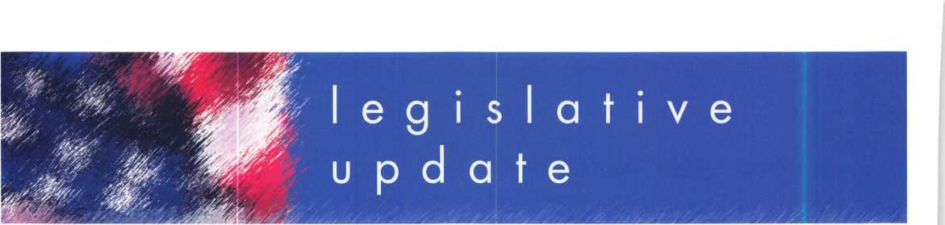

**ALOA LEGISLATIVE REPORT** (As of February 17, 2007)

**HI HB 188**

SPONSER: Evans TITLE: Locksmiths ABSTRACT:

Requires licensing for locksmiths. STATUS:

* 01/19/2007 Introduced and Pass First Reading.
* 01/22/2007 Referred to Consumer Protection Committee

**HI HB 423**

SPONSER: Herkes TITLE: Motor Vehicles ABSTRACT:

Requires motor vehicle manufactur­ers to allow registered owners through a registered locksmith to access information necessary to produce replacement keys.

STATUS:

* 01/19/2007 Pending introduc­tion.
* 01/22/2007 Introduced and Pass First Reading
* 01/22/2007 Referred to Consumer Protection Committee

**HI SB 1011**

SPONSER: Taniguchi TITLE: Motor Vehicles ABSTRACT:

Requires motor vehicle manufactur­ers to allow registered owners through a registered locksmith to access information necessary to produce replacement keys.

STATUS:

* 01/24/2007 Referred Consumer Protection Committee
* 02/15/2007 Public hearing scheduled on 02/21 at 9:30 am in conference room 016

**KY HB 481**

SPONSER: D. Graham

TITLE: AN ACT relating to motor

vehicles.

ABSTRACT:

Create a new section to prohibit any person from producing an ignition key or other device designed to operate a lock on a motor vehicle or start a motor vehicle for any person on the basis of a motor vehicle identifica­tion number (VIN) without obtain­ing and making a record of proof that the person requesting the ignition key or other device is the

owner or lessee of the motor vehi­cle or is a member of the same household as the owner or lessee of the vehicle.

STATUS:

* 02/14/2007 Introduced in House

**MD HB 903**

SPONSER: Davis, Impallaria, N. King, Montgomery, Myers, and Taylor

TITLE: Vehicle Laws - Consumer Access to Replacement Key Information ABSTRACT:

Requiring a manufacturer of a motor vehicle sold or leased in the State on or after January 1, 2010, to implement a system for provid­ing specified replacement key information to registered lock­smiths; requiring a motor vehicle manufacturer to make a specified key replacement system available to registered motor vehicle owners or lessees 24 hours a day and 7 days a week; establishing proce­dures for a registered locksmith and a motor vehicle manufacturer to follow to provide a replacement key to a motor vehicle owner or lessee; etc.

STATUS:

* 02/09/2007 H First Reading Economic Matters
* 02/14/2007 Hearing sched­uled 3/1 at 1:00 p.m.

**MD SB 707**

SPONSER: Hooper, Forehand, and Munson

TITLE: Vehicle Laws - Consumer Access to Replacement Key Information ABSTRACT:

Requiring a manufacturer of a motor vehicle sold or leased in the State on or after January 1,2010, to implement a system for provid­ing specified replacement key information to registered lock­smiths; requiring a motor vehicle manufacturer to make a specified key replacement system available to registered motor vehicle owners or lessees 24 hours a day and 7 days a week; establishing proce­dures for a registered locksmith and a motor vehicle manufacturer to follow to provide a replacement

key to a motor vehicle owner or lessee; etc.

STATUS:

* 02/02/2007 S First Reading Judicial Proceedings
* 02/07/2007 S Hearing 3/8 at 1:00 p.m.

**MT SB 153**

SPONSER: Vicki Cocchiarella TITLE: Revise professional and occupational licensing laws ABSTRACT:

Bill originally changed definition of "Security alarm system" to mean, "an assembly of equipment and devices or a single device, designed or a portion of a system intended to detect or signal or to both detect and signal unautho­rized intrusion, movement, or crim­inal acts at a location. AMEND­ED to provide for an exemption under "electronic security compa­ny" reading, "The term does not include a person whose primary business is that of a locksmith and who may also install closed circuit television cameras and battery- operated door devices"

STATUS:

* 01/18/2007 Hearing
* 02/02/2007 Amended
* 02/06/2007 Transmitted to House

**NJ A 2520**

SPONSER: Johnson, Gordon M. TITLE: Concerning electronic secu­rity systems and amending P.L.1962, c. 162.

SUMMARY:

This bill exempts businesses which install service or maintain access control systems, closed circuit tele­vision systems or intercom systems from licensure by the Board of Examiners of Electrical Contractors. Under current law, locksmiths, burglar alarm, fire alarm and electronic security busi­nesses, and their employees, are licensed and regulated by the board. This bill changes the defini­tion of "electronic security system" contained in the law so that it does not include access control systems, closed circuit television systems or intercom systems. STATUS:

* 02/09/2006 Introduced,

Referred to Assembly Regulated Professions and Independent Authorities Committee

**OK HB 1845**

SPONSER: Collins TITLE: Crimes and punishments; making certain acts unlawful; cod­ification; emergency.

ABSTRACT:

An Act relating to crimes and pun­ishments for possession of "bump keys".

STATUS:

* 02/05/2007 Authored by Representative Collins
* 02/06/2007 Second Reading referred to Judiciary and Public Safety

**OK SB 26**

**(Same as HB 1054)**

SPONSER: Jolley

TITLE: Professions and occupations and the Alarm and Locksmith Industry Act; deleting an exemp­tion. Effective date SUMMARY:

Exempts the sale, installation, serv­ice, or repair of alarm systems by individuals licensed pursuant to the Electrical Licensing Act under the Alarm and Locksmith Industry Act.

STATUS:

* 02/05/2007 Authored by Senator Jolley
* 02/06/2007 Second Reading referred to Business and Labor
* 02/06/2007 Pending author­ship Representative(s) Cooksey

**OK SB 632**

SPONSER: Barrington TITLE: Professions and occupa­tions; changing the Alarm and Locksmith Industry Act to the Alarm Industry Act. Emergency. ABSTRACT:

An Act relating to professions and occupations by amending the Alarm and Locksmith Industry Act by removing all reference to "lock­smith".

STATUS:

* 02/05/2007 First Reading
* 02/06/2007 Second Reading referred to Business and Labor

Keynotes • March 2007

**SC H 3104**

SPONSER: Umphlett TITLE: Locksmith licensing SUMMARY:

Provide for the licensure of lock­smith agencies, to require employ­ee registration, to require signed work order forms when opening residences, commercial establish­ments, and motor vehicles, and to provide penalties for certain viola­tions.

STATUS:

* 01/09/2007 House Referred to Committee on Labor, Commerce and Industry

**SC S 338**

SPONSER: Reese

TITLE: Tampering of a Security

Device

ABSTRACT:

To create an offence of tampering with, altering, damaging, or destroying a security device. Defines a security device to include alarm systems including, but not limited to, burglar alarms and other types of intrusion alarms or access control systems.

STATUS:

* 01/26/2007 Senate Referred to Subcommittee: Hutto (ch), Jackson, Knotts, Bryant

**TN HB 415**

SPONSER: Coleman TITLE: Locksmith Licenses ABSTRACT:

Repeals locksmith licensing provi­sions.

STATUS:

* 02/07/2007 Introduced
* 02/08/2007 Held pending Amendment

**TN HB 416**

SPONSER: Coleman TITLE: Locksmith Licenses ABSTRACT:

Requires the commissioner of com­merce and insurance to maintain a registry of current locksmiths and any disciplinary actions against them on the department's Web site.

STATUS:

* 02/07/2007 Introduced
* 02/08/2007 Held pending Amendment

**TN HB 1982**

SPONSER: DuBois

TITLE: Exemption from Licensure

ABSTRACT:

Exempts from licensure part-time locksmiths who earn less than $3,000 annually from providing locksmithing services.

STATUS:

• 02/15/2007 Introduced

**TN SB 515**

SPONSER: Tracy TITLE: Locksmith Licenses ABSTRACT:

Requires the commissioner of com­merce and insurance to maintain a registry of current locksmiths and any disciplinary actions against them on the department's Web site.

STATUS:

* 02/08/2007 Introduced
* 02/12/2007 Referred to Commerce Labor and Agriculture Committee

**TN SB 516**

SPONSER: Tracy

TITLE: LLocksmith Licenses

ABSTRACT:

Repeals locksmith licensing provi­sions.

STATUS:

* 02/08/2007 Introduced
* 02/12/2007 Referred to Government Operations Committee

**WA HB 1001**

SPONSER: Lovick

TITLE: Combating auto theft

SUMMARY:

Makes it a crime to possess a "motor vehicle theft tool" with the intent to commit a crime. Motor vehicle theft tool is defined as, "Slim jim, false master key, master purpose key, altered or shaved key, trial or jiggler key, slide ham­mer, lock puller, picklock, bit, nip- er, any other implement shown y facts and circumstances that is intended to be used in the com­mission of a motor vehicle related theft, or knowing that the same is intended to be so used.

STATUS:

* 01/10/2007 Public hearing in the House Committee on Public Safety & Emergency Preparedness
* 02/01/2007 Executive action taken in the House Committee on Public Safety & Emergency Preparedness
* 02/01/2007 PSEP - Executive action taken by committee
* 02/01/2007 PSEP - Majority;

1 st substitute bill be substituted, do pass

* 02/06/2007 Referred to Human Services
* 02/15/2007 Scheduled for public hearing in the House Committee on Human Services
* 02/14/2007 Scheduled for Executive Session in the House Committee on Human Services on

02/22 at 1:30 PM.

**WA HB 2243**

SPONSER: Quail

TITLE: Addressing the replacement of motor vehicle keys.

ABSTRACT:

Requires that a motor vehicle man­ufacturer of a new motor vehicle sold or leased in this state after December 31, 2008, shall pro­vide the registered owner of the motor vehicle, through a regis­tered locksmith, information neces­sary to permit the production of a replacement key or other function­ally similar device by the regis­tered locksmith that allows the reg­istered owner of the motor vehicle to enter, start, and operate the motor vehicle.

STATUS:

* 02/14/2007 First reading and referred to Commerce & Labor

**WA SB 5038**

SPONSER: Eide

TITLE: Combating auto theft

ABSTRACT:

Commission of a burglary or motor vehicle theft, this act adds the following language, "It shall be prima facie evidence of circum­stances evincing an intent to use for commission of a burglary or motor vehicle related theft for a person to be in possession of mul­tiple vehicle keys or altered vehi­cle keys unless such person is a bona fide locksmith."

STATUS:

* 01/08/2007 First reading, referred to Judiciary.

**JOIN ALOA'S LEGISLATIVE ACTION NETWORK TODAY!**

As a Legislative Action Network member, you will be "in the know" about the latest legislative happenings in your state. Each member will receive a quarterly newsletter giving them the latest insight to security legislation at the state and federal levels.

It's easy to join! Just send an email to [legislative@aloa.org](mailto:legislative@aloa.org) and puf'LAN" and your membership number in the subject line. We'll get you on the network right away!

If you contribute $100 or more to the Legislative Action Fund you become a member of the prestigious Legislative Action Network (LAN) Council. The Council is an important instrument in raising the standards of our profession through the legislative process by making sure that locksmiths have the final say in how our industry will be run. As a Council member, you will receive:

* The quarterly Legislative Action Network Update alerting you to important legislation in your state and around the country (same as LAN members)
* A comprehensive guide to lobbying in your state capital, so you can be the "voice of ALOA" to legislators.
* A lapel pin designating you as a special ALOA LAN Council member
* Recognition in Keynotes magazine.
* Invitation to exclusive functions at the annual ALOA convention for LAN Council members.
* Complimentary Legislative Convention merchandise.

It's simple to join the LAN Council:

* Log into the ALOA Store at <http://www.aloa.org/store>
* Click on Search and type in "Council"
* From there you can join at four different donor levels
* Add this to your basket and checkout!
* Note: if this is the first time you have used the ALOA Store since

December 2004, you will need to set up a username and password.

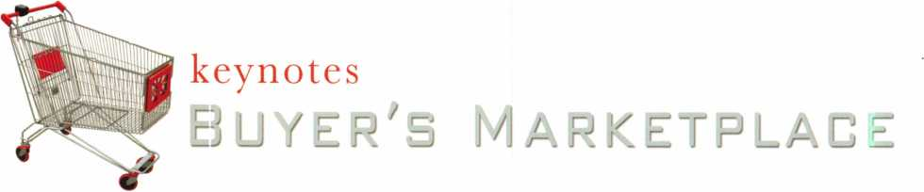

**r** FRONT &

P REAR-LOAD

**rjfT**i DEPOSITORY SAFES

FROM A & B SAFE CORP.

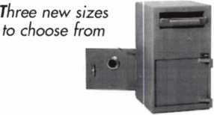

AB-8FL AB-8 RL AB-9-2 FL

A & B SAFE CORPORATION

114 S. Delsea Drive, Suite 3  
Glassboro, NJ 08028-6237  
856-863-1186 Fax 856-863-1208

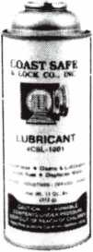

Using a general purpose lubricant? Be professionil! Use a specially formulated lubricant for the Locksmith and Safe Technician trade. You and your customers will be well pleased. Guaranteed!

$48°° + shipping per case.

12 -11 oz. cans per case minimum order.  
Order via phone or fax. Credit cards accepted.  
Net 30 W.A.C. or send check with order.

Coast Safe & Lock Co., Inc.

P.O. Box 66257 • Mobile, AL 36606  
(251) 479-5264 • Fax (251) 471-6967

Facts on Sargent punches.

These new hand operated punches have a few unique features, plus specifications that are worthy enough to mention.

Two models are available, BP201-SGT-L and BP201-SGT-R.

Depending on milling (profile), the blanks are inserted one side or the other. Example; The L series is inserted from the left side and cuts bow to tip. The R series is inserted from the right side and cuts tip to bow, similar to IC products.

If your need is greater for R series, then the BP201-SGT-R will generate them from bow to tip, and the L series tip to bow. Models L or R, each does both. The choice is yours.

SPACES:

.215" to first cut center .156" between cut centers up to  
seven spaces. Factory space tolerance is ± .001".

DEPTHS:

Are in increments of .020", from .330" to .150" for a total  
of 10 depths 1 - 0 (10). Factory tolerance is ± .002".

ANGLE:

Sharpest of most commercial specifications is 78 to 79 degrees.  
Tolerance if any is not specified by Sargent.

FLAT:

Small .051". No tolerance specified.

All of the above are incorporated in each hand punch by;

Locksmithing, Uni. LLC  
Phone: 302-575-0993  
E-mail: [ted@sargentpunch.com](mailto:ted@sargentpunch.com)

Keynotes • February 2007

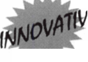

SCHLAGE

CAL-ROYAL

DOR-O-MATIC

J6CUfilTR0rCom^C

CHICAGO

23

**RCH**

LCN

***AUTOMOTIVE***

**■gp** DEMAND **41 lockcraft^**

**fc*A$P *DETERMINATOR***

***MAJOR HAT A***

***ifton £* >LQK**

W STRATTEC

***VISA***

***ACCESS C0HTK01***

**VON DUPRIN tt-LCARA**

ComdC

NATIONAL

**VisalocK**

_ OLYMPUS ^

CbmZKL0CK'INC

^ FORT

ASSA CornfK

1MBERUNE

NORTO

***PADLOCKS***

**Master Lock**

_ th

*vAnniyersary*

**Since 1912**

DON-IO ‘ J

Jk RROW

VON DUPRIN

*roots*

® *DlHim Ml*

**A A F**3**TJ;**

***(&¥£T-CODE***

**AVENGER**

&



We are celebrating 95 years  
of saving you money!

*H.L. Flake Co.*

800-231-4105

WE SAVE YOU MONEY ON SHIPPING!

Place your order by 5 PM CST  
& get your order before noon the next day!

**LOCKCRAFTgg**

**BIANCHI**

**(LAB)** MAJOR

PRO-LOK

***utCLfl***

l *locksmith htols MM* %2fc^y58MLSf

***HATASmai***

**nKACLO.**

*Wedgec&~*



**-4105**

■



WI*3*

**MERIGON LOCK**

**INDUSTRIAL GRADE SECURITY**

jb

**LIST $655**

iM

DL2700 26D

Shop around and you will see that our  
push button lock prices are the best!

Q5th

*^Sa n n i versary*

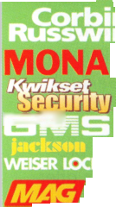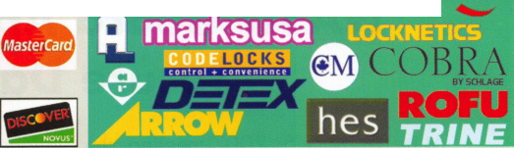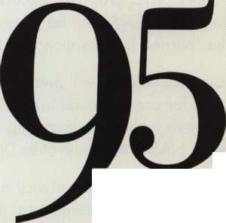

NASTF Board Approves Pilot Testing For  
Secure Data Release Model

At its February 5, 2007 meeting, the National Automotive Service Task Force (NASTF) Board of Directors approved the NASTF Vehicle Security Committee's (VSC) proposed Secure Data Release Model (SDRM) for pilot testing. A presentation and demonstration of the SDRM will be given during the next NASTF General Meeting on April 17, 2007 at 1:30 pm at the Marriott Renaissance Center in Detroit, Michigan.

"The SDRM and its Automotive Security Professional Registry will give automakers a flexible system to pro­vide 24/7 access to vehicle security information for pre-approved locksmiths and technicians. It allows after- market service providers to support consumer needs without undermining the integrity and basic purpose of vehicle security systems." said Mary Hutchinson, NASTF Administrative Director.

The VSC has grappled with numerous issues including customer privacy and security, locksmith/ technician liability and insurability, and the needs of automakers, law enforcement, the professional locksmith communi­ty, and independent repairers. The VSC thoroughly vetted these issues with stakeholders and cooperatively developed the SDRM and Registry concept.

The SDRM is designed to provide a nationwide infrastructure for access to various types of security data and service support systems. For example, automakers can use the system to provide access to key codes, immobilizer PINs and reset systems, radio codes, etc.

Eight auto manufacturers (representing about two-thirds of vehicles sold) are already actively engaged in development of the SDRM and Registry infrastructure. These automakers and others are expected to join the upcoming pilot testing. The VSC implementation timetable is as follows:

* Board of Directors' Approval - February 2007 (achieved)
* Pilot testing begins - March 2007
* Begin build-out of system components - May 2007
* Registry acceptance testing - July/August 2007
* Begin locksmith/technician registration - September 2007
* Final Production Testing - November/December 2007
* Fully Operational - January 1, 2008

"This is an exciting example of NASTF fulfilling its mission to facilitate the identification and correction of gaps in the availability and accessibility of automotive service information" said Charlie Gorman, Chairman of NASTF. "The Vehicle Security Committee and the various segments of the automobile industry working on this project can be very proud of their accomplishments."

Gorman added, "NASTF would like to thank all members of the Vehicle Security Committee for their resolve in working through this complicated task. We also extend our special thanks to the Associated Locksmiths of America, the Automotive Service Association, the National Insurance Crime Bureau and the participating automakers for their commitment of human and financial resources to make this project possible."

A link will be added to the NASTF website later this summer pointing interested parties to additional infor­mation and the Registry enrollment process.

NASTF was established in 2000 to identify, communicate and resolve gaps in the availability and accessibility of automotive service information, service training, diagnostic tools, and equipment for the benefit of automotive service professionals and their customers. NASTF was incorporated in 2006. Additional details can be found at [www.nastf.org](http://www.nastf.org).



Keynotes • March 2007

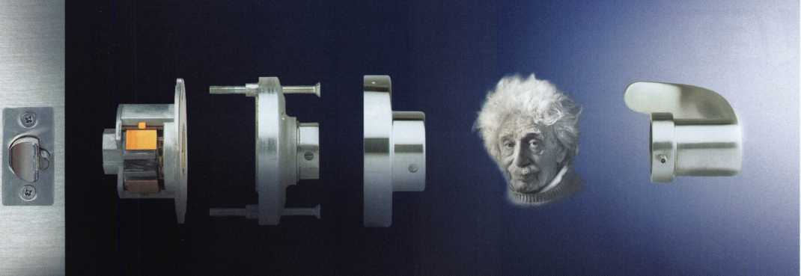

**Simons = Voss**

**technologies**

Copyright ® 2007 by SimonsVoss Technologies Inc.

[www.simons-voss.us](http://www.simons-voss.us)

**IT’S SMART. JUST LIKE YOU.**

It's the SV-1 Door Lock System from SimonsVoss - the world’s first electronic access control system entirely contained inside the handle.

Easily installed anywhere a cylindrical or mortise lock is used, you cut installation costs, slash operating expenses and significantly reduce security risks with features like fully encrypted communications, instant transaction recording and proven resistance to mechanical, electrical and magnetic attacks.

Backed by more than a decade of German engineering, this very technology can be found in some of the most

o

important buildings on earth today. It’s time to experience

*the beauty of a keyless world.*

KW1 +

**EASTER LOCK & KEY** k 325-3535 /

USDVA

ILLINOIS

A-1 KEY & LOCK  
j 24HR SERVICE  
312-555-1234

Dl PLICATION PROHIBITED

**Smart Clone**

**For All Cloneable Keys... Including Ford, Infiniti & Toyota**

**Professional Products for Professional Locksmiths**

**Smart Clone Key Blanks**

**Largest Selection of Groovy Keys Anywhere**

**Displays and Key Assortments**

**Precision Key Machines and Cutters**

**Master Keying and Fine Duplication**

**View Our Complete Line of Professional Locksmith Hardware at**

**[www.jetkeys.com](http://www.jetkeys.com)**

**Jet**

**Exclusives**

**Uni Bow Neuter Bow Personal Line**

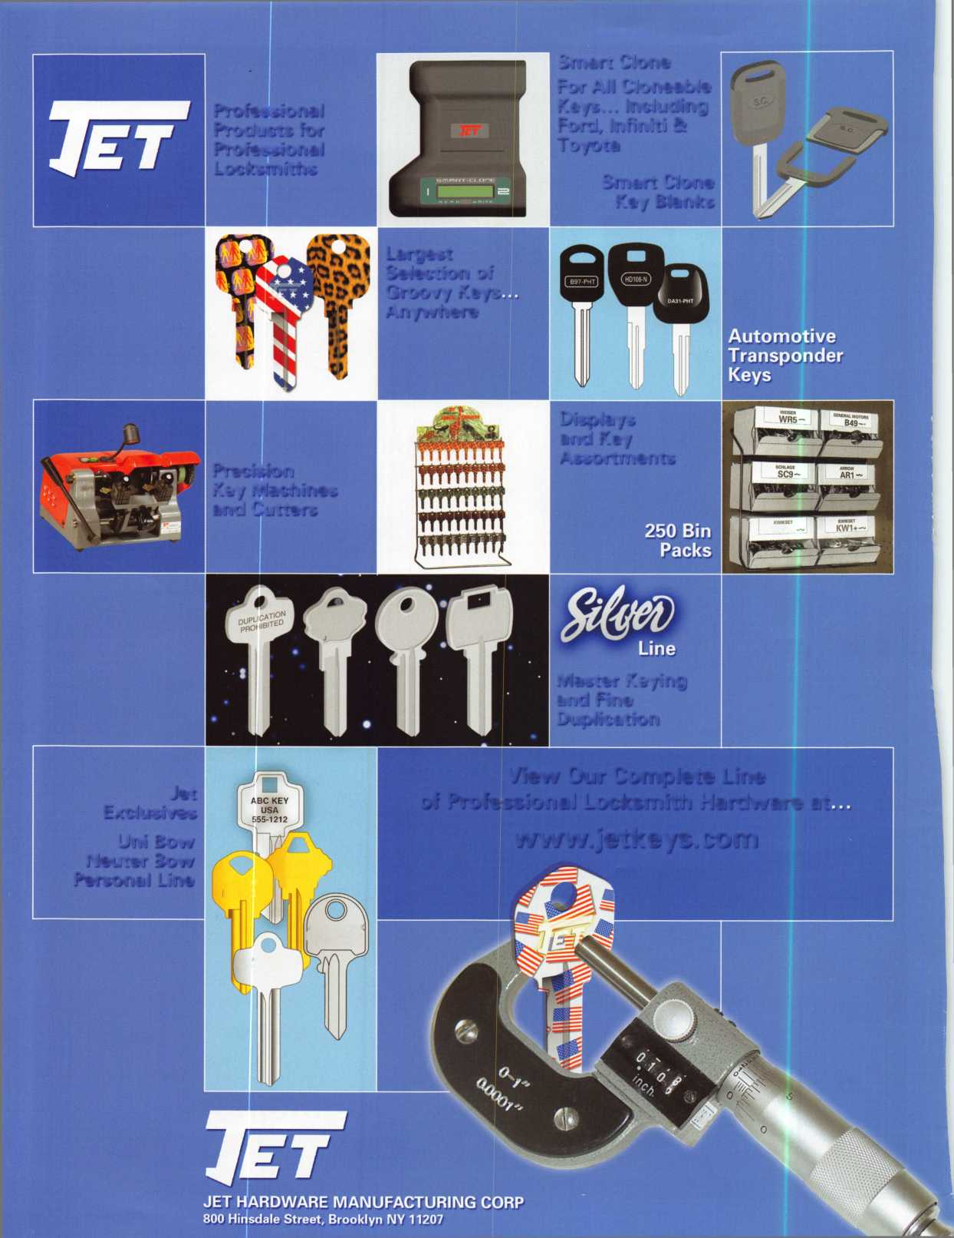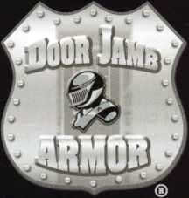

**cause You Can’t Afford falsa Secnril**

**Fixed**

**Save Time, Make Money**

Repairing a broken doorjamb  
used to take hours. Now  
in less than an hour, you can

fix broken jambs and help

prevent repeat offenses. Stop  
giving good business away to

your carpenter.

he Hinge Shields fit around the existing loor hinges and help prevent hinges from leing kicked in

9 Door Shield

‘he Door Shield reinforces the lock area of he door and helps prevent the door from ;plitting when kicked. Low profile model s available in colors to match your locks

SpJamh Shield

The backbone of the system, the Jamb Shield is a 48" long sleeve that wraps around the lock side of the doorjamb, making it extremely difficult to kick in. The Jamb Shield comes sizes to fit Standard (5.5") and Universal (5" to 12") lock spacing. Jamb and hinge shields

Current security products only alert homeowners that they have already been violated.

Your customers will actually be able to sleep secure the night after a break-in. Helps eliminate tenant initiated damage and secures vacant units for landlords.

This Will Change Your Business

* You should make $1,000 on every call that you answer with this product
* Calling a carpenter to fix shattered jambs costs you money
* This will help you sell more high-end deadbolts

w Hr» \/rm \A/nrl/ \A/ith an\/ lanrllnrrlQ?

\) Hinge Shield

Your Customers Need This

**wiicic ltd**

**Heeded Most**

**A unique system that  
reinforces the key strike  
points on entry doors  
and repairs damage  
from previous kick-ins**

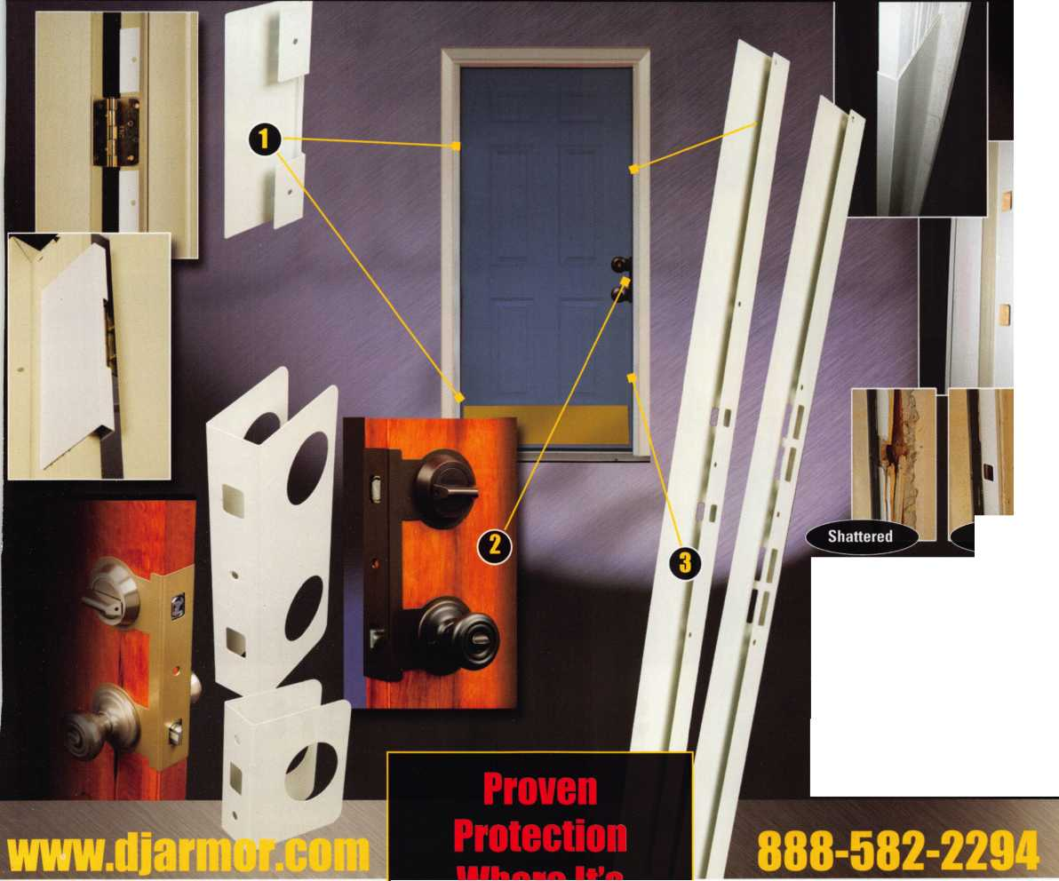

**SearchAlert**

* Available in a variety of colors and styles
* Recognized & Accepted by the TSA
* Security Window cannot be altered with a paper clip
* Security Window can only be reset by a person knowing the combination
* Zinc Die Cast Body (Not Brittle Plastic)
* Steel Shackle is virtually unbreakable

Security Window

O

**Red Window:**

Luggage has been searched.

O

**Green Window:**Lock Not Opened.

The new SearchAlert Security window changes color from Green to Red when the TSA secured access device is used to open the lock, or when an unauthorized person has opened the lock using a counterfeit opening device. Travelers will now know when their SearchAlert Classic locks have been opened, and whether their bags have been searched by a TSA agent, or violated by an

unknown person. Protected by U.S. Patents 6,877,345 and 7,007,521. The Design of the Lock is a Registered Trademark of The Eastern Company.

***The name ifou can Trash for Travel safety, security it account,****'ability.*



**Security Products** A Division of The Eastern Company **A Proud Union Company. (S.E.I.U.)**301 West Hintz Road | Wheeling, IL 60090 | Telephone: 800.733.8588 | Fax: 847.537.1881  
**[www.cclsecurity.com](http://www.cclsecurity.com)**



**TRAVEL SENTRY**

**APPROVED**

